Melba Marie (Oubre) Collins

April 28th, 1945 - November 14th, 2019

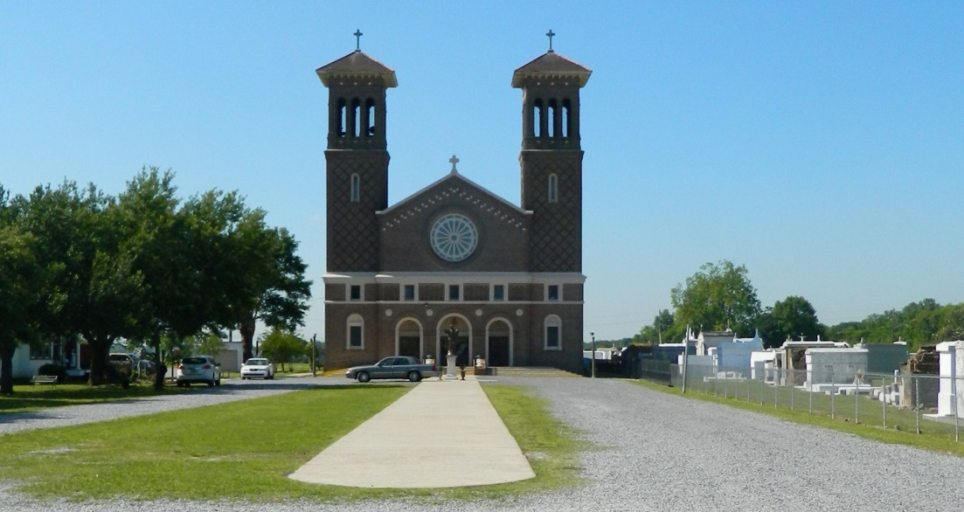

Melba Oubre Collins, resident of Edgard, LA and native of Vacherie, LA peacefully entered into eternal rest on November 14, 2019 at Ochsner Extended Care Hospital at the age of 74. Melba is survived by her husband Alvin E. Collins Jr., children Alvin Collins III, Dean Collins, and Angel Collins; siblings Elry Oubre (Celeste), Judy Fiffie (Victor), Marvelyn Wesley (Wayne), Flora August, and Gerard Oubre; sister-in-law Eva Bierra; and a host of nieces, nephews, family and friends.   
 Melba was preceded in death by her parents Snell and Leonise Oubre, father and mother-in-law Earl and Eleanor Pembrook, sister Sandra Oubre Edwards, brothers-in-law Allen Edwards and Edward “Joey” August, and niece Catina Oubre.   
 We would like to express our sincerest gratitude to Ochsner Extended Care Hospital for the exceptional care they provided.   
 All neighboring communities and churches, St. John the Baptist Parish School Board employees, former Our Lady of Grace school colleagues, and employees of Ochsner Extended Care Hospital are invited to join the family for a Mass of Christian Burial at St. John the Baptist Catholic Church,2349 LA-18, Edgard, LA 70049 on Friday, November 22, 2019 at 11am, Rev. Msgr. Terry Becnel officiating. Visitation at 9:00am until service time. Entombment at St. John the Baptist Catholic Church Cemetery, 2349 LA-18, Edgard, LA 70049. Final care entrusted to Treasures of Life Funeral Services, 315 E. Airline Highway, Gramercy, LA 70052.

Treasure of Life Funeral Services, Gramercy, LA

Accessed 1/29/2020