Sonia Ann (Jasmin) Cox

November 24, 1942 - June 15, 2022

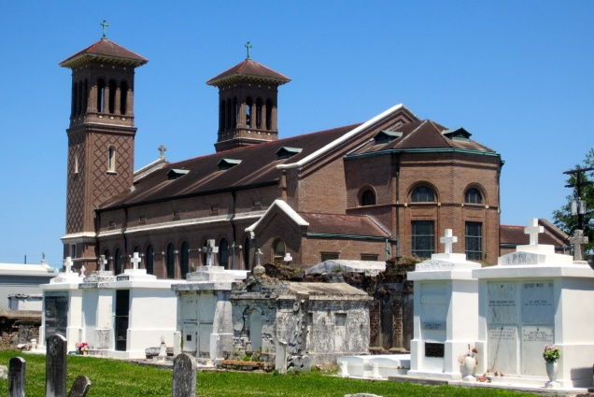

Sonia Ann Jasmin Cox transitioned to her heavenly home on June 15, 2022. She was born to the late Romalis Jasmin and Amanda Boudoin Jasmin on November 24, 1942 in New Orleans, LA. Sonia had no blood siblings, but her 1st cousin Catherine Numa was raised from childhood as her only Sister.

Sonia was the wife of Leroy Warren Cox.  Sonia married Leroy Warren Cox in 1961 and would have been celebrating almost 61 years of matrimony.  To this union Sonia & Leroy were the Proud Parents of four daughters. Reonda Cox Victor (Thaddeus)-LaPlace, LA, Andrea Cox Loyd (Kenneth)-Marietta, GA, Deon Cox-Dallas, TX and Tammy Cox-LaPlace, LA. Sonia also had one bonus daughter Tanja Numa (Dwayne) Dutton of Dallas, TX.

Sonia better known as “Maw-Maw” was the doting grandmother of 7 grandchildren.  Tiffany A. Victor, Tayler R. Loyd, Thaddeus R. Victor, Jordan K. Loyd, Kelsey A. Joseph, Sydney S. Joseph & Donte L. Woolen. Sonia was recently blessed to be the Great-Grandmother of now 1 year old Romalis Thaddeus Victor. Sonia also loved & acknowledged Tanja Numa Dutton’s children as Grandchildren; Danielle Rideau, Kolby & Irie Razor- Dallas, TX.

Sonia was christened at Saint John the Baptist Catholic Church in Edgard, LA where she was a lifetime parishioner.  She was an active member of the Knights of Peter Claver Ladies Auxiliary, Court #66 where she served for 49 years. Sonia simultaneously served on the Sick Committee where she visited and prayed for the sick in the community regardless of their affiliation. In addition to these accolades, she was also a member of the Ladies of Distinction social & community group for 30 years. Sonia began her education in the public school system of St John the Baptist Parish in Edgard, LA. She graduated from Second Ward High School- Class of 1961. She later attended Business School and became an Office Assistant. She had several careers, Office Assistant, Cafeteria Staff and Seamstress. She also worked in retail for nearly 20 years between TG&Y and Walmart.

Relatives and friends of the family, Priests, Officers and Members of St. John the Baptist Catholic Church and all surrounding churches are invited to a Mass of Christian Burial at 10:00 a.m., Saturday, June 25, 2022 at St. John the Baptist Catholic Church, 2349 Hwy-18, Edgard, LA  70049. Rev. Robustiano Morgia-Celebrant. In accordance with the CDC guideline for COVID-19 mask are suggested for all in attendance. Visitation 8:00 a.m. at the above-named church until time of Mass. Recitation of the Most Holy Rosary will begin at 9:00 a.m. Interment St. John the Catholic Baptist Church Mausoleum. Final Arrangements entrusted to Patrick H. Sanders Funeral Home & Funeral Directors, Inc. 605 Main Street, LaPlace, LA  70068. For information 985-359-1919.

If you wish to honor the memory of Sonia Cox in lieu of flowers, please donate to the Knights of Peter Claver Ladies Auxiliary Court #66. Sonia was a dedicated member for 49 years and volunteered her time and resources toward the service of others.  They provide scholarships to high school graduates, assistance and resources to a local battered women's shelter, assistance to families in need, resources to local elementary school-aged children, and support to their local church. All donations will be handled by Edward Jones Financial.

The Patrick H. Sanders Funeral Home, LaPlace, Louisiana