Norman C. Darensbourg

September 27, 1940 – October 16, 2019

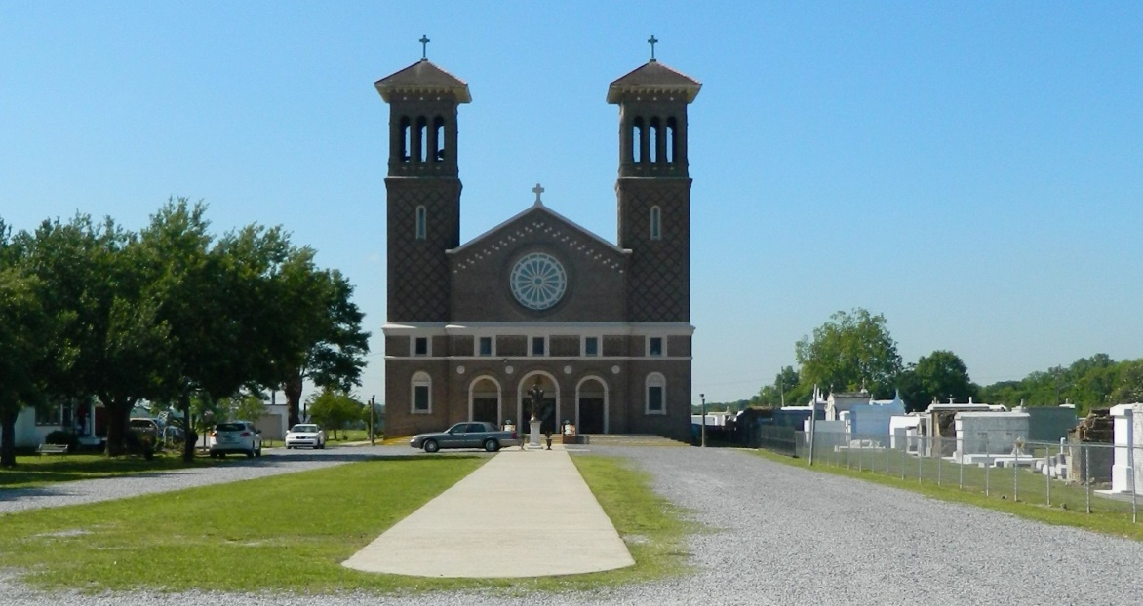

Norman C. Darensbourg on Wednesday, October 16, 2019 at Chateau Living Center, Kenner, LA. Born to the late Authur and Beatrice Mitchell Darensbourg on September 27, 1940. Husband of the late Evelyn Cannon Darensbourg. Father of Shelita Jackson (Randy), Carey Darensbourg, Daphne Shallerhorn, Ron Darensbourg (Hope) and the late Norman Darensbourg, Jr. Brother of Bessie St. Amant, the late Gladys Davis, Oscar, Clarence, Alfred, Fellman, Nuffy and Sterline Darensbourg. Also survived by 11 grandchildren, 14 great grandchildren and a host of nieces, nephews, cousins, other relatives and friends. Age 79 years. A native and resident of Lucy, LA. Retired employee of Avondale Shipyard. Relatives and friends of the family, also priest and parishioners of St. John the Baptist Catholic Church and all neighboring churches, employees of Ochsner Medical Center, Chateau Living Center, Kenner, LA and Egan Hospice are invited to attend the Funeral Mass at St. John the Baptist Catholic Church, 2349 Highway 18 (River Road), Edgard, LA on Saturday, October 26, 2019 at 10:00 AM. Rev. Robustiano Morgia, Celebrant. Interment St. John the Baptist Cemetery, Edgard, LA. Visitation at the above named church from 8:00 AM until Mass time. SERVICED BY ROBOTTOM

Published in The Times-Picayune on Oct. 25, 2019