Lelia (Calvey) Dinvaut

February 5, 1920 – September 11, 2019

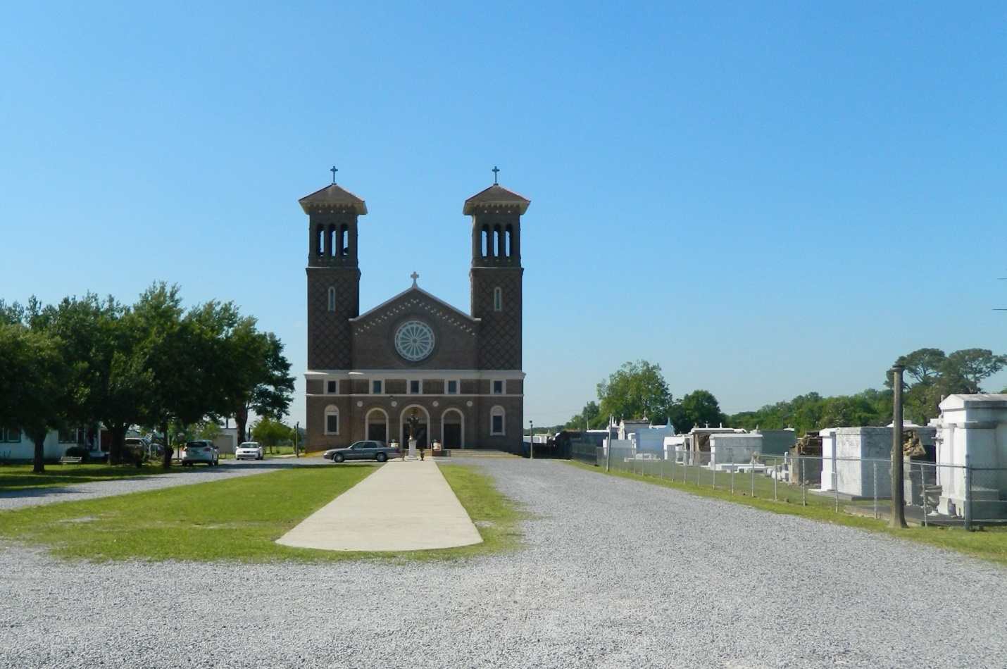

Lelia Calvey Dinvaut was born on February 5, 1920 in St. James Parish to the late Wallace Calvey and Lelia M. Calvey. Lelia worked in the St. John the Baptist Parish School System for 34 years as an educator. On September 11, 2019, Lelia departed this earthly life. She is survived by her beloved son Linwood Dinvaut (Sharazana) and brother Frank Calvey, five grandchildren; Ryan Dinvaut (Jacquelyn), Chantell and Janell Dinvaut, Jessica Auguillard (Eugene) and Thaddeus Dinvaut, Jr., seven great-grandchildren, two great great-grandchildren, and many nieces and nephews. She is preceded in death by her beloved husband of 62 years, Joseph Dinvaut, her parents; Wallace Calvey and Lelia Monconduit Calvey, her son; Thaddeus Joseph Dinvaut, Sr., four sisters; Leona Calvey LeBeouf (Albert), Onita Calvey Brossett (Ellis), Irma Calvey, Ruth Calvey Cantrelle (Dave), and one brother; Matthew Calvey. A Mass of Christian burial will be held at St. John the Baptist Catholic Church, 2349 LA-18, Edgard, LA 70049 on Friday, September 20, 2019 at 10 a.m. Visitation will begin at 8 a.m. followed by the Rosary at 9:00 a.m. Final care has been entrusted to Treasures of Life Funeral Services, 315 E. Airline Hwy Gramercy, LA 70052.
Published in The Times-Picayune from Sept. 19 to Sept. 20, 2019

