Van Sinclair Dupree
June 15, 1974 – March 12, 2025

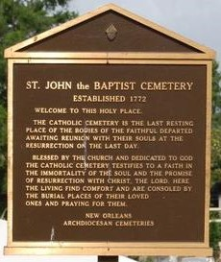

On March 12, 2025, Van Sinclair Dupree was called from this life to the next as he passed away peacefully in his sleep at home at the age of 50. Van was born on June 15, 1974 in New Orleans, LA to Isaac Dupree and Ann Alexander Dupree.
He was a lifelong resident of Bridge City, LA. In his youth, Van attended St. Rita Elementary School in New Orleans, and was a graduate of Archbishop Shaw High School and Xavier University of Louisiana. After college, Van worked various jobs, but for the last six years was employed at the Ogden Museum of Southern Art in New Orleans.
Van enjoyed reading, watching sports (he was one of the few people in the City who watched Hockey), playing games on his XBox and being surrounded by friends and family.
Van is survived by his brother Corwin Dupree, his father Isaac Dupree (Beverly); his mother Ann Alexander Dupree; his god daughter Tonya Smith; 3 aunts, Frances Dupree, Ann Cooper, and Marble A. Pierre; 1 uncle Samuel Smith; and host of other relatives and friends.
The family would like to invite family and friends to a public visitation on Friday, March 21, 2025 at Our Lady of Prompt Succor, 146 4th St., Westwego, LA 70094 from 9:00 AM to 12:00 PM. A Mass of Christian Burial will follow. Rite of Committal (Burial) St. John The Baptist Catholic Church Cemetery, 2349 LA-18, Edgard, LA 70049.

Treasures of Life Funeral Service, Gramercy, Louisiana
March 19, 2025

