Pumphile Steven Duronslet

December 26, 1929 – August 22, 2011

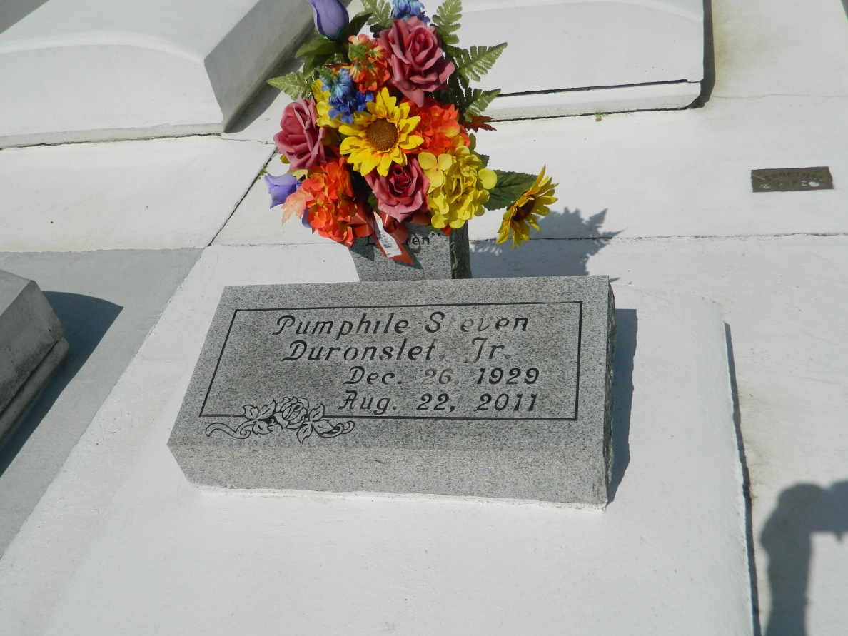

Pumphile Steven Duronslet, Jr., passed away on Monday, August 22, 2011 at 11:30 a.m. at his life long residence in Lucy, LA. Beloved husband of Betty Thompson Duronslet for 62 years. He is survived by sons: Marcus (Debra), Kevin (Cynthia), DeRayne (Marcita) Duronslet; daughters: Marietta (Thaddeus) D. Dinvant, Roslyn (Michael Sr.) Roussell, Gesele (Kerry) Sabathia, Yvette (Richard) Bernard, and Kim Duronslet (deceased); seventeen grandchildren, eleven great-grandchildren, and a host of nephews and nieces. He was born December 26, 1929, to the late Pumphile, Sr. and Mathilda Duronslet. Brother of Emile, Sr. (Janica), Oneal, Sr. (Deola), Lloyd (Patrice), Henry, Sr. (Phyllis), deceased are Romain Sr., Curtis Sr. (Mona and Nadine) Duronslet, and one sister Philomeno (Ferdinand) Dinvant. Pumphile, better known as "Lighten" to friends and family was loved by those who knew him. Relatives and friends are invited to attend the Christian Mass at St. John the Baptist Catholic Church, 2361 Hwy. 18, Edgard, LA on Friday, August 26, 2011 at 11:00 a.m. Visitation from 9:00 a.m. until time of service. Father Joel Cantones will officiate. Arrangement by the Baloney Funeral Home LLC. 399 Earl Baloney Street, Garyville, La. 985-535-2540. Guest may sign the register at:  
[www.baloneyfuneralhome.com](http://www.baloneyfuneralhome.com/)

Times-Picayune, The (New Orleans, LA) - Thursday, August 25, 2011

Contributed by Jane Edson