Robert C. Duronslet Sr.

March 4, 1929 – December 3, 2007

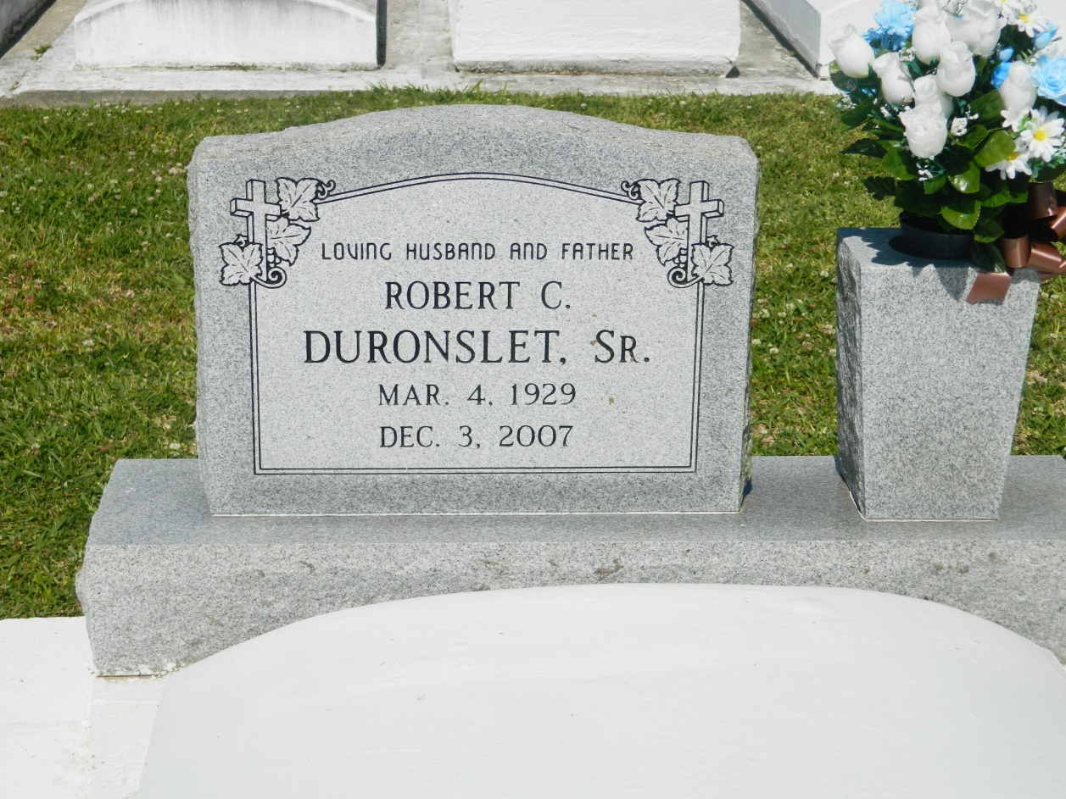

Robert C. "Paw-Paw" Duronslet, Sr. on Monday, December 3, 2007 at his daughter's home in Vacherie, LA. Son of the late Elizey and Bertha Louper Duronslet, Sr. Loving husband of the late Hazel Lumar Duronslet. Father of Rosalyn Littles, Donna Echols, Tina Aubert, Ann Traylor, Tammy Hart, Rickey, Michael, Steven, Craig and Keith Duronslet and the late Robert Duronslet, Jr. Brother of Geraldine Thomas, Sedonia Mitchell, Delphine Young , Sheral Isom, Clifford Duronslet, the late Thelma D. Joseph and Elizey Duronslet, Jr. Also survived by 31 grandchildren, 4 great grandchildren, and a host of nieces, nephews, other relatives and friends. Age 78 years. A native and resident of Lucy, LA.  
  
Relatives and friends of the family, also priest and parishioners of St. John the Baptist Catholic Church and all neighboring churches are invited to attend the Mass of Christian Burial at St John the Baptist Catholic Church, Edgard, LA on Saturday, December 8, 2007 at 11:00 AM. Father Joel Cantones, Celebrant. Interment Church Cemetery. Visitation at the above named church from 9:00 AM until Mass time.  
  
SERVICED BY ROBOTTOM

Times-Picayune, The (New Orleans, LA) - Friday, December 7, 2007

Contributed by Jane Edson