Isabelle Marie (Amedee) Dutreix
January 18, 1917 – October 15, 2024

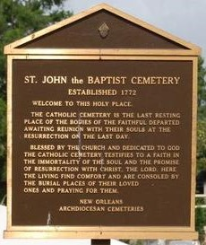

Isabelle Marie Amedee Dutreix passed away on Tuesday, October 15, 2024 at the age of 107. She was born in Vacherie, LA.
Beloved wife of the late Harold R. Dutreix, Sr. Loving mother of Shirley Blenderman (the late Ronald), Ronald Dutreix (Sylvia), Harold Dutreix, Jr. (Gerry), Conley Dutreix (Jessie) and Chris Dutreix (Sandra). Daughter of the late Amazelle Sarpy Amedee and Stephen Amedee. Also survived by 17 grandchildren, 31 great grandchildren and 24 great-great grandchildren.
Relatives and friends are invited to attend the Visitation and Funeral Mass at St. Philip Catholic Church, 1175 LA-18, Vacherie, LA on Monday, October 21, 2024. Visitation will be held at the church from 10:00 a.m. to 11:00 a.m. followed by a Funeral Mass at 11:00 a.m. Interment in St. John the Baptist Cemetery, Edgard, LA.
In lieu of flowers, the family is requesting donations to the American Red Cross or a charity of your choice.

Rose Lynn Funeral Home, Lutcher, Louisiana
October 17, 2024

