Josef Daniel Echols

April 8, 1951 – March 22, 2009

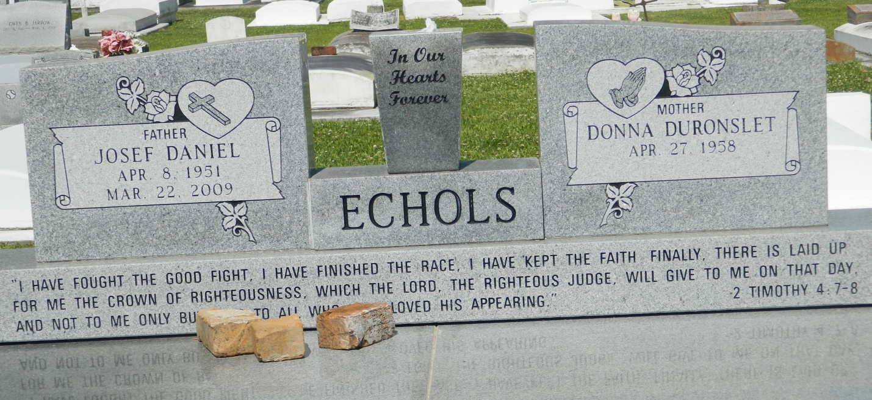

Josef Daniel Echols on Sunday, March 22, 2009 at St. James Parish Hospital, Lutcher, LA. Son of the late Joseph Dock Echols and Ruth Demas-Echols. Beloved husband Donna Duronslet Echols. Devoted and proud father of DeHaven Duronslet of Baton Rouge, LA and Jalen Josef Echols of Edgard, LA. Brother of Ivory Brown and surrogate sister Rhonda Brown of New Orleans, LA. Uncle of Sonia Arceneaux and Ira Caston of New Orleans, LA. Brother in law of Rosalyn D. Littles, Rickey (Bev) Duronslet, Michael (Vanessa) Duronslet, Steven (Rona) Duronslet, Sr., Tina (Vaughn) Aubert, Ann (David) Traylor, Craig (Anita) Duronslet, Sr., Tammy (Jeffery) Hart, and Keith (Alexis) Duronslet, Sr. the late Robert Duronslet, Jr., Clifton Littles, and Dwayne Pollard. Son in law of the late Robert Duronslet, Sr. and Hazel Lumar Duronslet. Godson of Sedonia Mitchell. Also survived by two God children, Maya Gauthier and Kierra Spiller, and a host of other relatives and friends. Age 57 years. A native of New Orleans, LA and a resident of Edgard, LA.  
  
Relatives and friends of the family, also priest and parishioners of St John the Baptist Catholic Church and all neighboring churches and employees of Monsanto Chemical Company, St John the Baptist Parish Council, East Baton Rouge Fire Department, and parents, students, faculty and staff of Reserve Christian School are invited to attend the Mass of Christian Burial at St John the Baptist Catholic Church, 2361 Highway 18, Edgard, LA on Saturday, March 28, 2009 at 11:00 AM. Father Joel Cantones, Celebrant. Interment Church Cemetery. Visitation at the above named church from 9:00 AM until Mass time. Recitation of the Rosary at 9:45 AM  
  
SERVICED BY ROBOTTOM

Times-Picayune, The (New Orleans, LA) - Friday, March 27, 2009

Contributed by Jane Edson