Edward Gaines, Sr.

February 12, 1923 – June 30, 2004

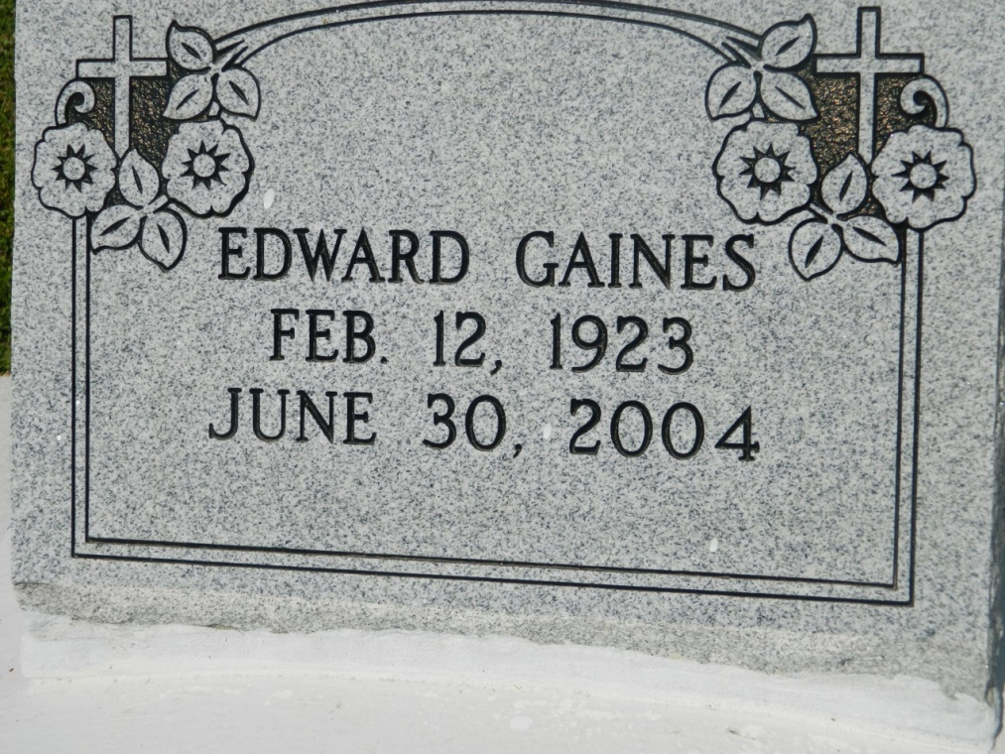

EDGARD - Edward "CB" Gaines Sr., 81, a native of Thibodaux and resident of Edgard, died June 30. He was the husband of Dorothy Lumar Gaines and father of Heidi and Edward Gaines Jr.  
  
He was also the son of the late Griffin and Cornelius Gaines, and brother of Fannie Lewis. He is preceded in death by brothers and sisters.  
  
He is also survived by five grandchildren and one great-grandchild.  
  
Services are today at 11 a.m., at St. John the Baptist Catholic Church, Edgard, with interment at the church cemetery. Visitation starts at 9 a.m.

L'Observateur (La Place, LA) - Sunday, July 4, 2004

Contributed by Jane Edson