Noelia (Meadoux) Gauthier

December 9, 1924 – December 6, 2002

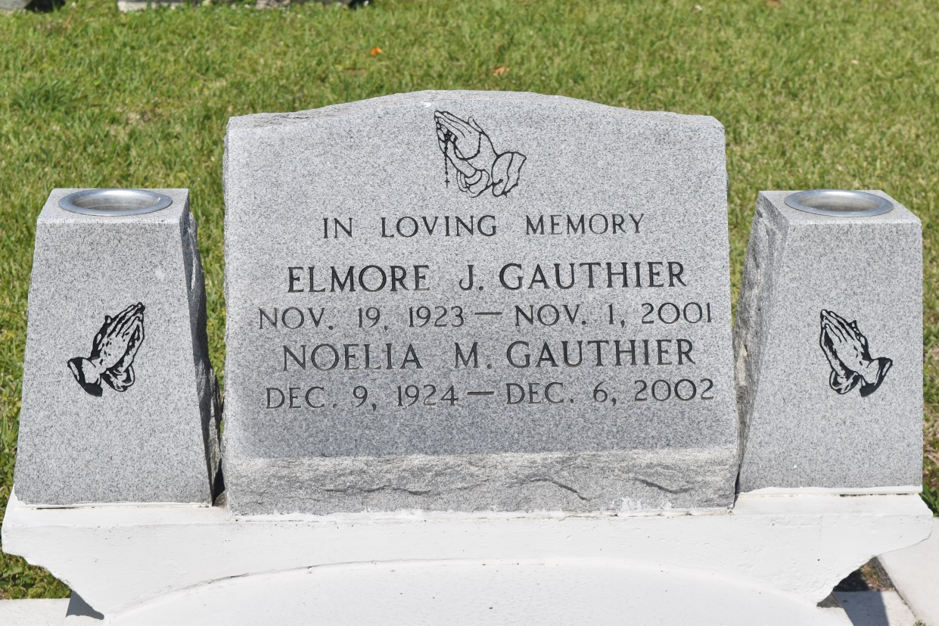

EDGARD - Noelia Meadoux Gauthier, 77, a native and resident of Lucy, died Dec. 6. She was the wife of the late Elmore Gauthier and mother of Marie and Adam Gauthier Sr.  
  
She was the daughter of the late Louise and Nelson Meadoux and sister of Zenobia Augusta, Pearl Pierre, Alice Miller and Lester and the late Louis Meadoux.  
  
She is also survived by three grandchildren and one great-grandchild.  
  
Services were Dec. 13 at St. John the Baptist Catholic Church with interment at the church cemetery.

L'Observateur (La Place, LA) - Thursday, December 19, 2002

Contributed by Jane Edson