Audrey (SoraPuru) Gautier

January 24, 1929 – December 4, 2017

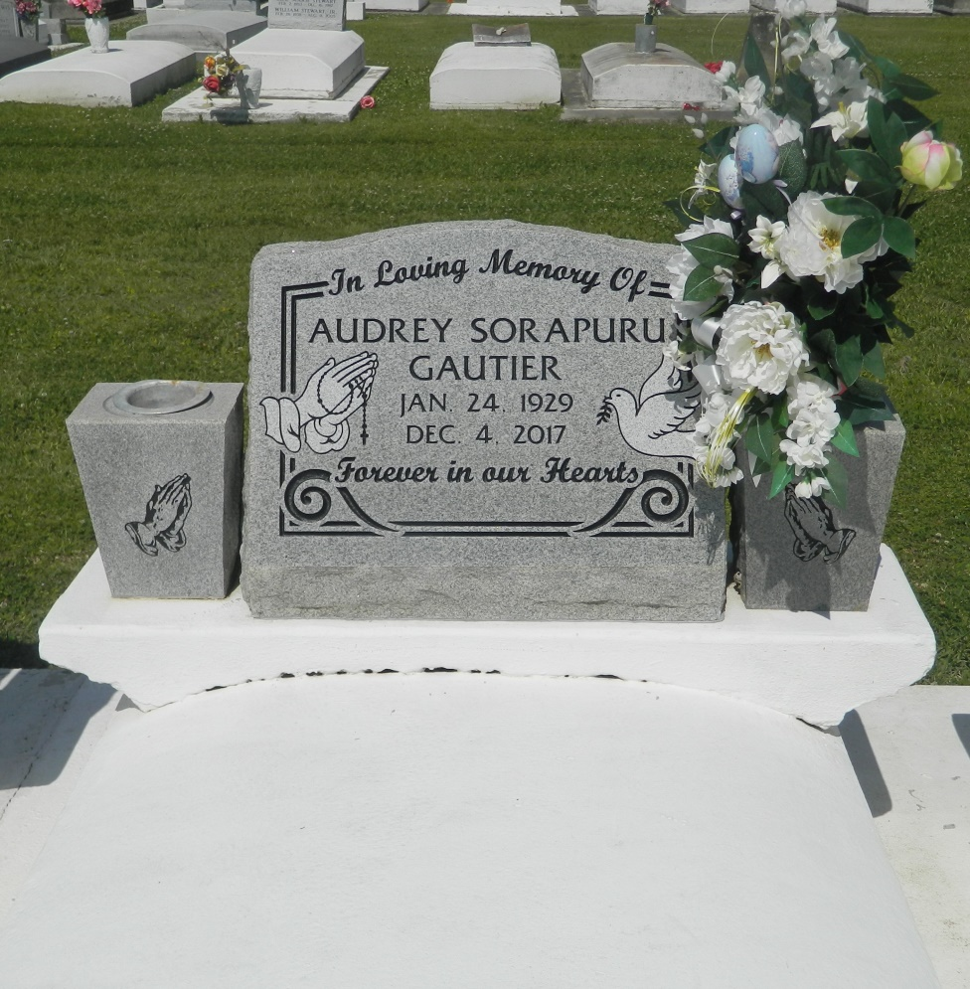

Audrey Sorapuru Gautier on Monday, December 4, 2017 at East Jefferson General Hospital, Metairie, LA. Daughter of the late Honorine Meadoux and Wilbert Marine Sorapuru. Wife of the late Perry John Gautier. Mother of Margaret Brown, Marlene Dapremont (Peter), Karen Mitchell (Dennis), Charlene Davis (Kenneth), Keith Gautier (Michelle), Eric Gautier (Nancy), David Gautier, Leslie Ross (Reginald), Shane Gautier and Janice' Salone (Lawrence). Sister of Bertha Sorapuru, Olga Boudoin, Theresa Adam, Larry Sorapuru, Sr., the late Thelma Barre, Stanley and Leroy Sorapuru. Also survived by 19 grandchildren, 18 great grandchildren and a host of nieces, nephews, cousins, other relatives and friends. Age 88 years. A native and a resident of Lucy, LA. Relatives and friends of the family, also priest and parishioners of St. John the Baptist Catholic Church and all neighboring churches are invited to attend the Funeral Mass at St. John the Baptist Catholic Church, 2349 Highway 18 (River Road), Edgard, LA on Monday, December 11, 2017 at 11:00 AM. Rev. Robustiano Morgia, Celebrant. Fr. Joel Cantones, Co-Celebrant. Interment St John the Baptist Catholic Church Cemetery, Edgard, LA. Visitation at the above named church from 9:00 AM until Mass Time. Rosary at 9:45 AM SERVICED BY ROBOTTOM

Published in The Times-Picayune on Dec. 10, 2017