Georgiana O. Gautier

May 28, 1906 – May 18, 2005

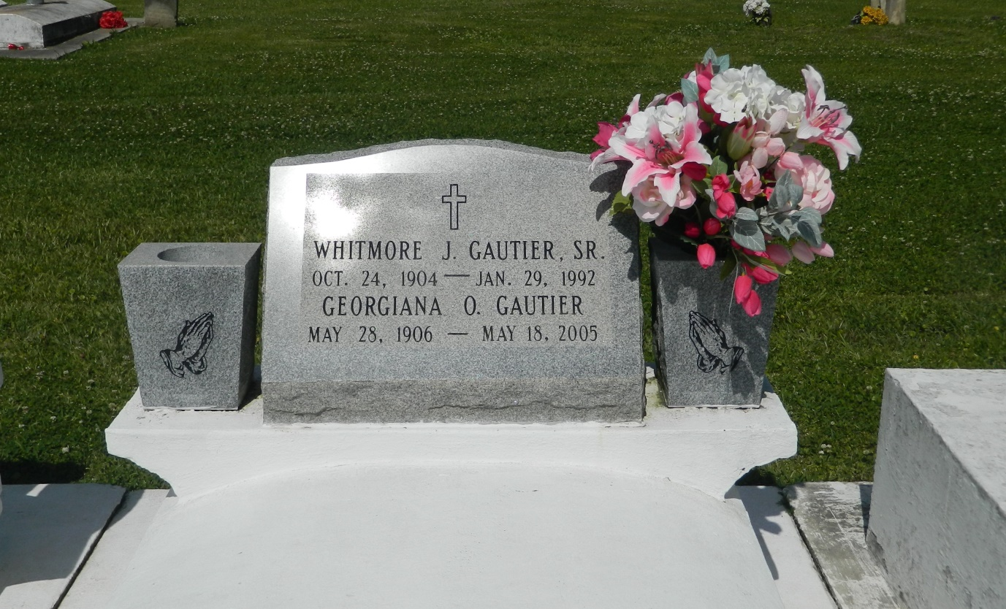

Georgiana O. Gautier, a homemaker, died Wednesday at Luling Living Center. She was 98.

Ms. Gautier was born in Vacherie and lived in Wallace for the past 65 years. She was a member of the Good Children Society. Survivors include three sons, Larry and Elwood Gautier and Whitmore J. Gautier Jr.; three daughters, Allison G. Roussel, Deola G. Duronslet and Lois A. Gautier; 36 grandchildren; 28 great-grandchildren; and six great-great-grandchildren.

A Mass will be said Monday at 11 a.m. at St. John the Baptist Catholic Church, 2361 Highway 18 in Edgard. Visitation will begin at 9 a.m. Burial will be in the church cemetery. D.W. Rhodes Funeral Home is in charge of arrangements.

Times-Picayune, The (New Orleans, LA) - Sunday, May 22, 2005

Contributed by Jane Edson