Janie Mae (Anderson) Gautier

November 23, 1936 – December 30, 2013

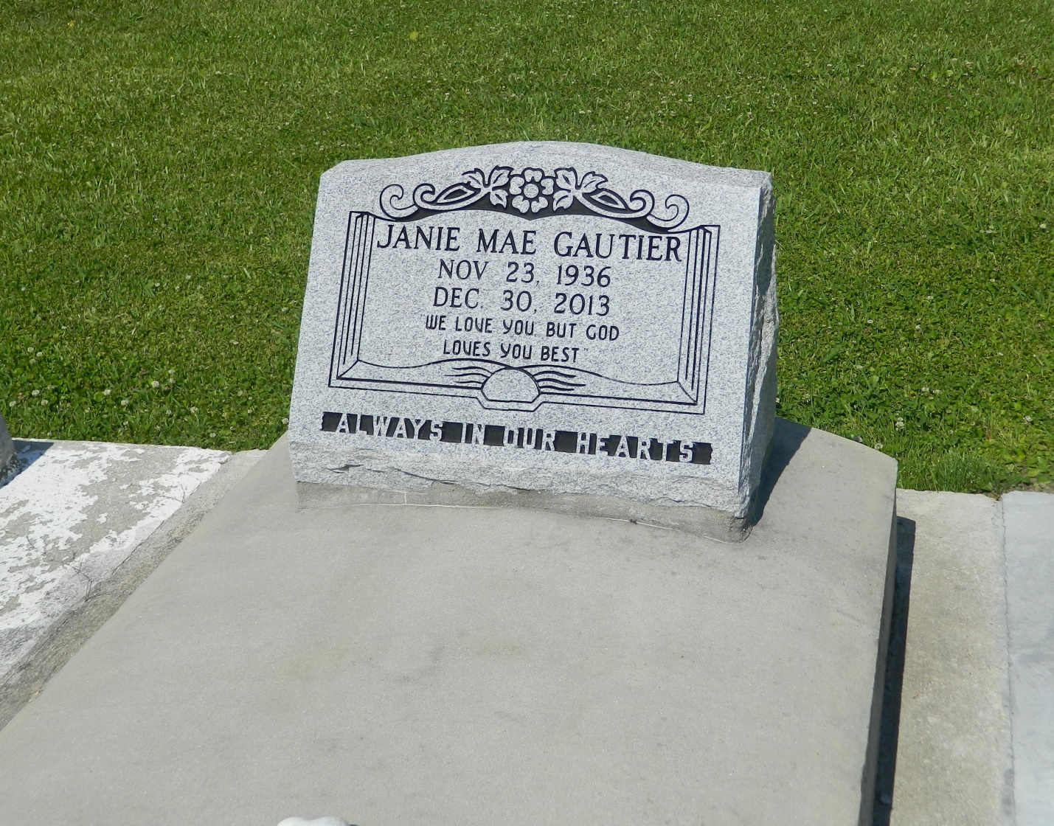

Janie Mae Anderson Gautier at the age of 77 yrs. on Monday, December 30, 2013 departed this earthly life. Beloved wife of Thaddeus Gauthier Sr. Loving mother of Germaine Jett of Duluth, GA, Andrea Gautier-Craf (Warren) of Douglasville, GA, Paulette G. Whitehead (Jimmy) of New Orleans, LA, Thaddeus Gautier (Yvette), Dennis Gautier, both of New Orleans, LA , and the the late Herman Anderson (Cherol). Daughter of the late Sam and Sarah Anderson. Also survived by seven grandchildren, nieces, nephews, other relatives, and friends.  
  
Relatives and friends of the family, also Priest and Practitioners of St. John the Baptist Catholic Church of Edgard, LA and all neighboring churches are invited to attend the funeral service on Saturday, January 4, 2014, at 11:00a.m. at St. John the Baptist Catholic Church at 2349 Hwy 18, Edgard, LA. Father Robustiano Morgia Celebrant. Interment in Church cemetery. Visitation will be at the above named church from 9:00a.m. until service time.  
  
Bardell's Mortuary of Mt. Airy, LA in charge. Information: 985-535-6837

Times-Picayune, The (New Orleans, LA) - Friday, January 3, 2014

Contributed by Jane Edson