Perry John Gautier

October 4, 1927 – May 14, 2002

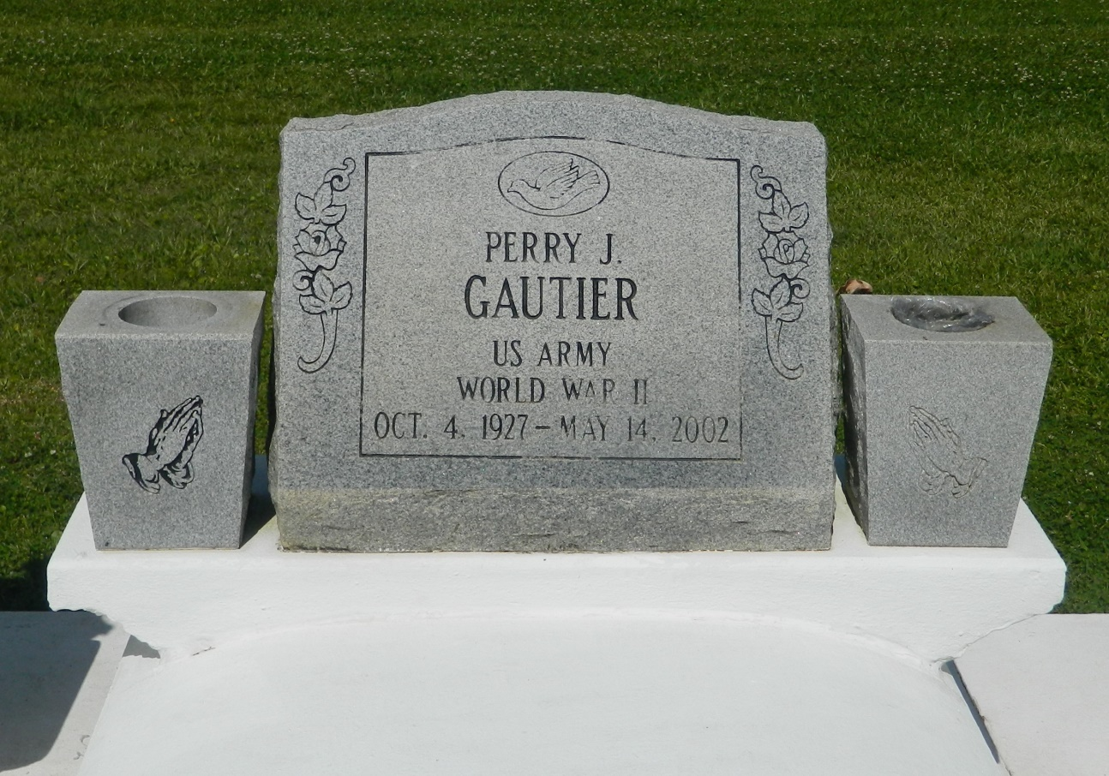

EDGARD - Perry John Gautier, 74, a native of Wallace and resident of Lucy, died May 14. He was the husband of Audrey Sorapuru Gautier and father of Margaret Brown, Marlene Dapremont, Karen Mitchell, Charlene Davis, Leslie Ross and Ja'Nice, Keith, Eric, David and Shane Gautier.  
  
He was the son of Georgiana Oubre Gautier and the late Withmore Gautier Sr. and brother of Allison Roussell, Deola Duronslet and Lois, Stanford, Larry, Withmore Jr. and Elwood Gautier.  
  
He is also survived by 16 grandchildren and two great-grandchildren.  
  
He was a U.S. Army veteran of World War II and a retired employee of Avondale Shipyard of 42 years.  
  
Services are today at 10 a.m. at St. John the Baptist Catholic Church, Edgard, with interment at the church cemetery. Visitation starts at 8 a.m.

L'Observateur (La Place, LA) - Tuesday, May 21, 2002

Contributed by Jane Edson