Stanford Joseph Gautier

December 9, 1950 – October 6, 2003

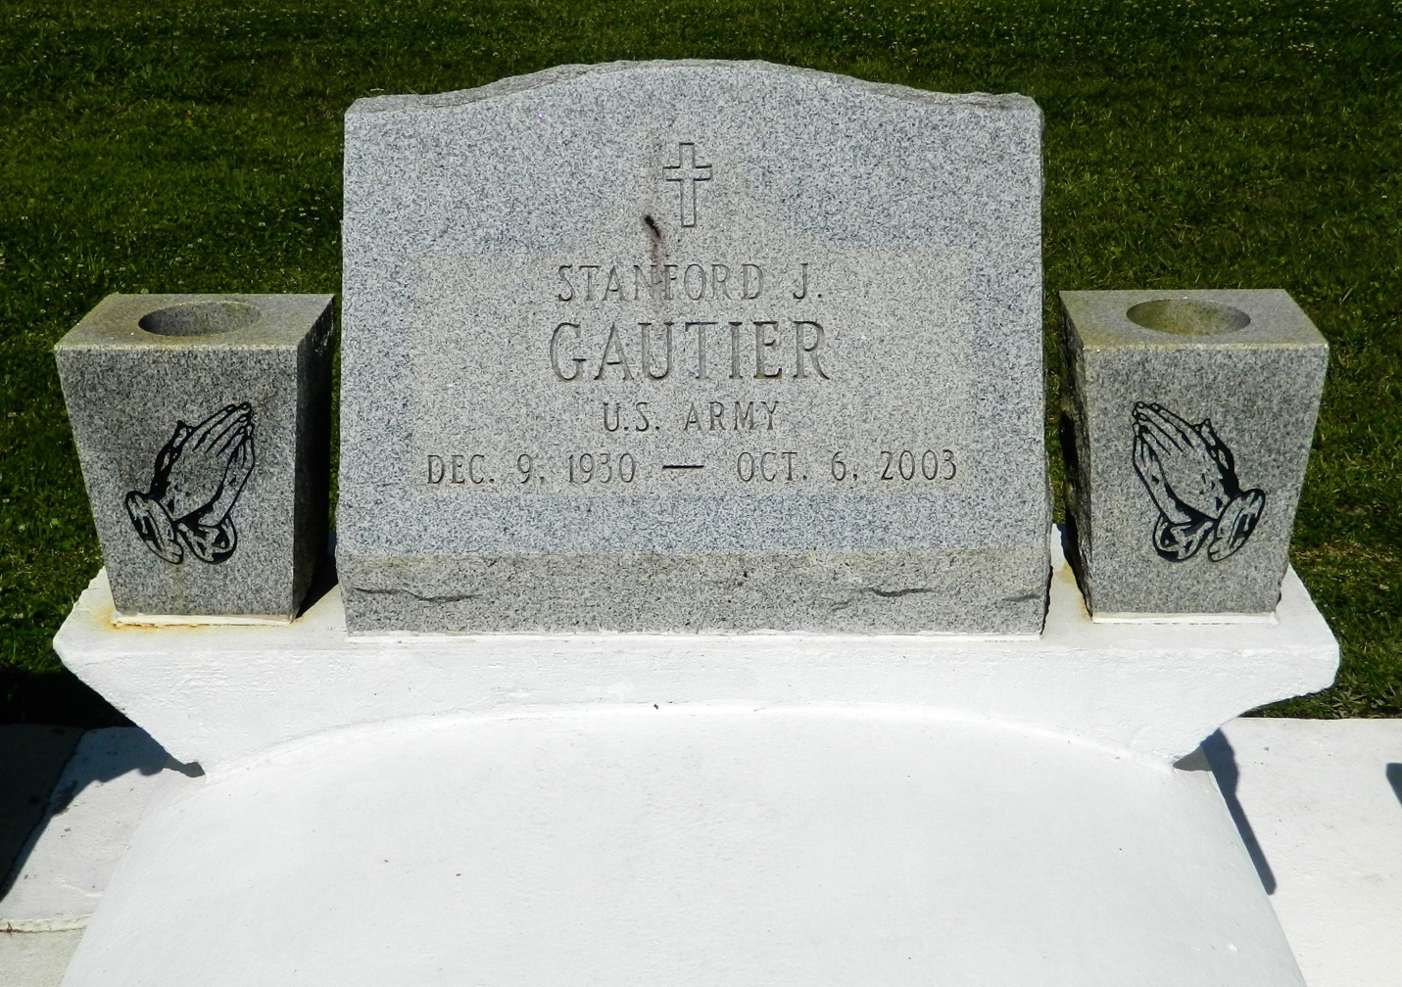

Stanford Joseph Gautier, Sr. on Monday, October 6, 2003 at Veterans Administration Hospital, Denver, CO. Son of Georgiana Oubre-Gautier and the late Whitmore Gautier. Father of Kenneth, Karla, Stanford, Jr., Erica, Stephens, Jeanise, and Cecelia Gautier. Brother of Whitmore, Jr., Allison Roussell, Deola Duronslet, Lois, Larry and Elwood Gautier and the late Perry Gautier. Survived by 1 grandchild and a host of nieces, nephews, cousins, other relatives and friends. A native of Edgard and a resident of Denver, CO for the past 25 years. Age 72 years.  
  
Relatives and friends of the family, also priest and parishioners of St. John the Baptist Catholic Church and all neighboring churches are invited to attend the Mass of Christian Burial from St. John the Baptist Catholic Church, 2361 Highway 18, Edgard, Louisiana on Tuesday, October 14, 2003 at 11:00 A.M. Interment Church Cemetery. Visitation at the above named church from 9:00 A.M. until service time.  
  
SERVICED BY ROBOTTOM

Times-Picayune, The (New Orleans, LA) - Monday, October 13, 2003

Contributed by Jane Edson