Stephen Remy Gautier

May 11, 1972 – August 23, 2014

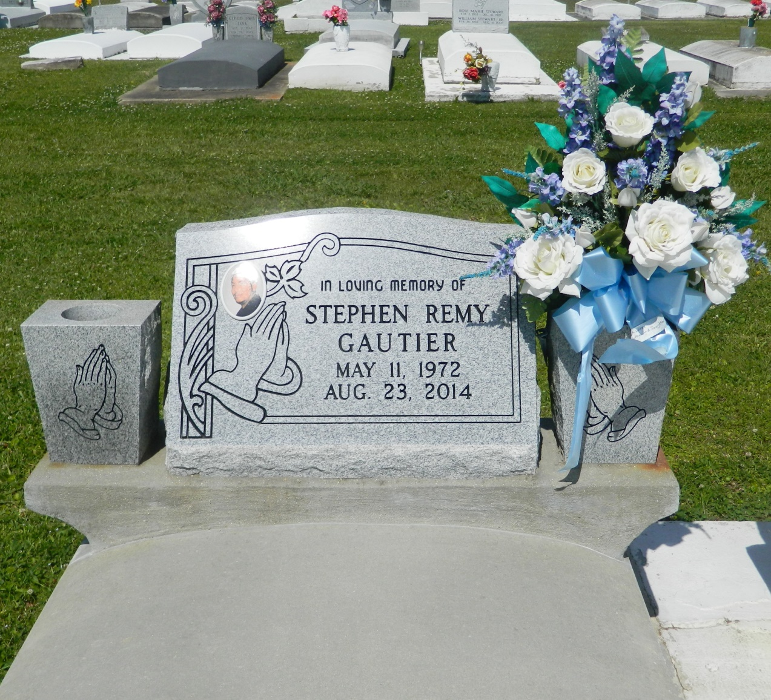

STEPHEN REMY GAUTIER on Saturday, August 23, 2014 at his home in Hahnville, LA. Son of Patricia Dinvaut and the late Stanford J. Gautier, Sr. Father of Jai Brian Gautier and Joshua Walker. Brother of Kenneth D Gautier, Stanford J. Gautier, Jr., Karla S. Gautier, Erica C. Gautier and Jeanise M. Gautier. Grandfather of Chase Gautier. Also survived by a host of nieces and nephews, cousins, other relatives and friends. Age 42 years. A native and a resident of Hahnville, LA.  
  
Relative and friends of the family, also priests and parishioners of St. John the Baptist Catholic Church and all neighboring churches are invited to attend the Funeral Mass at St. John the Baptist Catholic Church, 2361 Highway18 (River Road), Edgard, LA on Saturday, August 30, 2014 at 11:00 AM. Father Robustiano Morgia, Celebrant. Interment St. John the Baptist Cemetery, Edgard, LA. Visitation at the above named church from 9:00 AM until Mass time.  
  
SERVICED BY ROBOTTOM

Times-Picayune, The (New Orleans, LA) - Friday, August 29, 2014

Contributed by Jane Edson