Maurice Anthony Gosserand Jr.

August 10, 1976 – September 25, 2004

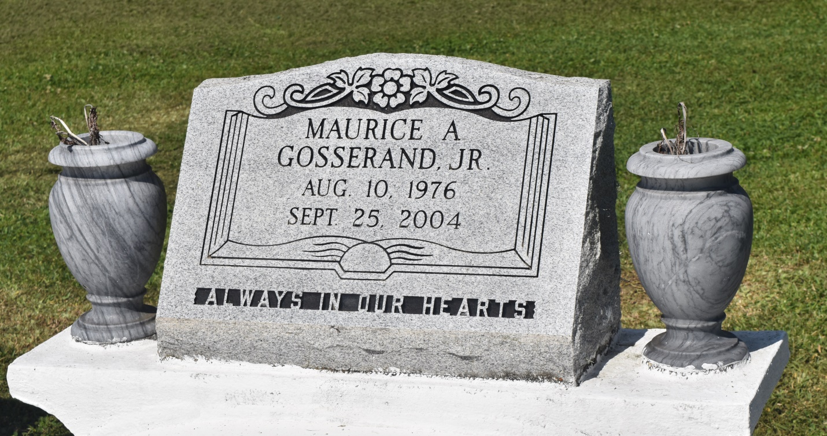

Maurice Anthony Gosserand Jr., a mechanic, died Saturday of gunshot wounds at Charity Hospital. He was 28. Mr. Gosserand was born in New Orleans and lived in Metairie for the past six months.

Survivors include his wife, Alexandra Gosserand; a daughter, Mauricia M. Gosserand; his father, Morris A. "Tony" Gosserand Sr.; his mother, Dardenella Lapeyrolerie Gosserand; three brothers, Bryce Williams and Michael and Jean-Pierre Gosserand; a sister, Kenya Gosserand; and his grandmother, Elizabeth "Hattie" Gosserand.

A Mass will be said today at 9:30 a.m. at St. Clement of Rome Catholic Church, 3717 Richland Ave. Visitation will begin at 9 a.m. Burial will be in St. John the Baptist Church Cemetery. Majestic Mortuary is in charge of arrangements.

Times-Picayune, The (New Orleans, LA) - Friday, October 1, 2004

Contributed by Jane Edson