Virgul Goudia

1946 – May 19, 2018

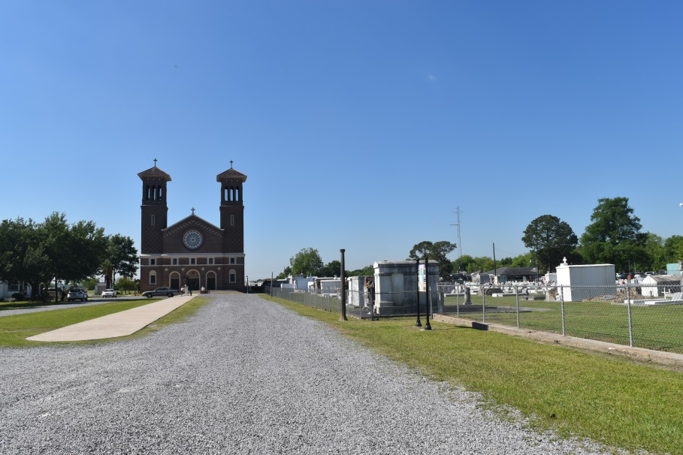

Virgul “Wolf” Goudia, age 71, passed away peacefully on Saturday, May 19, 2018 at the Carpenter House of St. Joseph Hospice. Son of the late Irvin Louis Goudia and Yvonne Walker Goudia. He leaves to cherish his memories his beloved wife, Cassondra Pierre Goudia, children Elitha G. Washington (Ronald), Mary G. Clark (Markus) and Ederique Goudia. Step children Shannica Bethancourt (Brian), Sheeronda and Brandon Pierre. Sister, Marsha (Ronnie) Reed of Bellflower, Ca. Grandchildren, Sherizan, Ethan, Austyn Landry, Elijah Bolds, Madyson Mays, and Eliannah and Elyahkeem Goudia; great grandchildren Harmonie, Amarielle, Ava, Hunter Cortez, Quentin Pitterson and Addilyn Landry. Devoted cousin Sylvia Mitchell, a host of nieces, nephews, cousins and friends. Preceded in death by siblings Kernell, Felton, Glenn Sr., Dale Goudia and Gwendolyn G. Trench. Virgul was a dedicated worker at Azalea Fleet Inc. (AEP) in Waggaman, La. for many years until his health began to fail. Relatives and friends of the family also priest and parishoners of St. John the Baptist Catholic Church, St. Philip Catholic Church, Second Ward High School Class of 65, and Azalea Fleet are invited to attend a Mass of Christian Burial on Friday May 25, 2018 at 10:00 am from St. John the Baptist Catholic Church 2349 Hwy. 18 Edgard, La. Father Robustiano Morgia, celebrant. Visitation at the church after 8:00 am. Recitation of the rosary at 9:00 am. Entombment church mausoleum. There will be a gathering of friends on Thursday, May 24, 2018 from 5-7 pm at Treasures of Life Funeral Services, 315 E. Airline Hwy., Gramercy, La. 70052. Final care entrusted to Treasures of Life Funeral Services.  
“When someone you love becomes a memory that memory becomes a TREASURE”

[www.treasurefunerals.com](http://www.treasurefunerals.com) (accessed 6/26/2018)