Albin Joseph Granier

Mary 10, 1901 – January 1, 1979

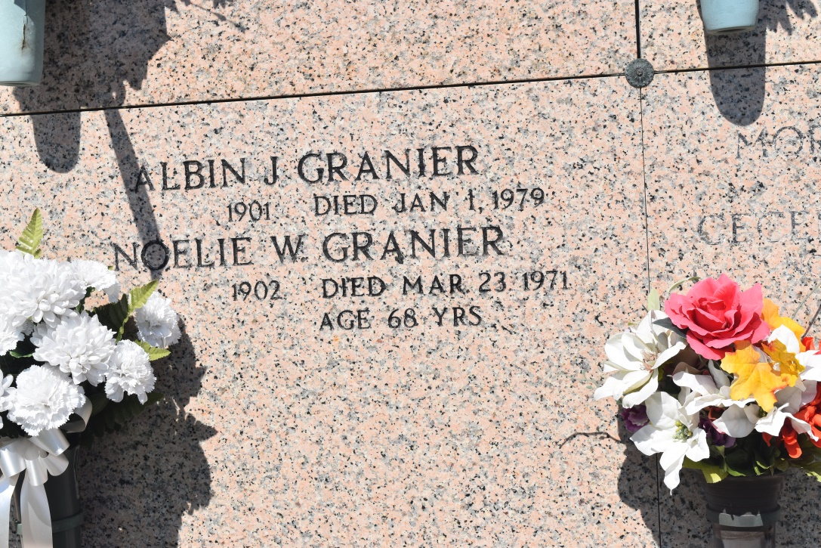

Albin Granier

Funeral services were scheduled for 10 a.m. Wednesday at the Edgard Center in Edgard for Albin Granier Sr., 71, who died Monday at 1:18 a.m.

Religious services will follow at the St. John the Baptist Catholic Church in Edgard with interment in the church mausoleum.

A native of Whitecastle and a resident of Vacherie, he was the husband of late Noelie Waguespack; father of Joyce Martines?, Rosalyn Hanner?, Dorothy Ordoyne, Noelle, Theriot, Dolly Mae Cortes, Lucille Aguillar?, Warren S., Arthur, V??? J., Albin Jr., and Henry? Granier; brother of ??? Granier and the late Lee Granier; son of the late Colleen Lorio and Henry Granier.

Friends may call after 5 p.m. today.

The Daily Comet, Thibodaux, LA; Tuesday, January 2, 1975, p. 14, c. 1

Transcribed by M Pearce - Note: scan is very dark and difficult to read