Henry J. Grenier

June 29, 1933 – May 18, 2015

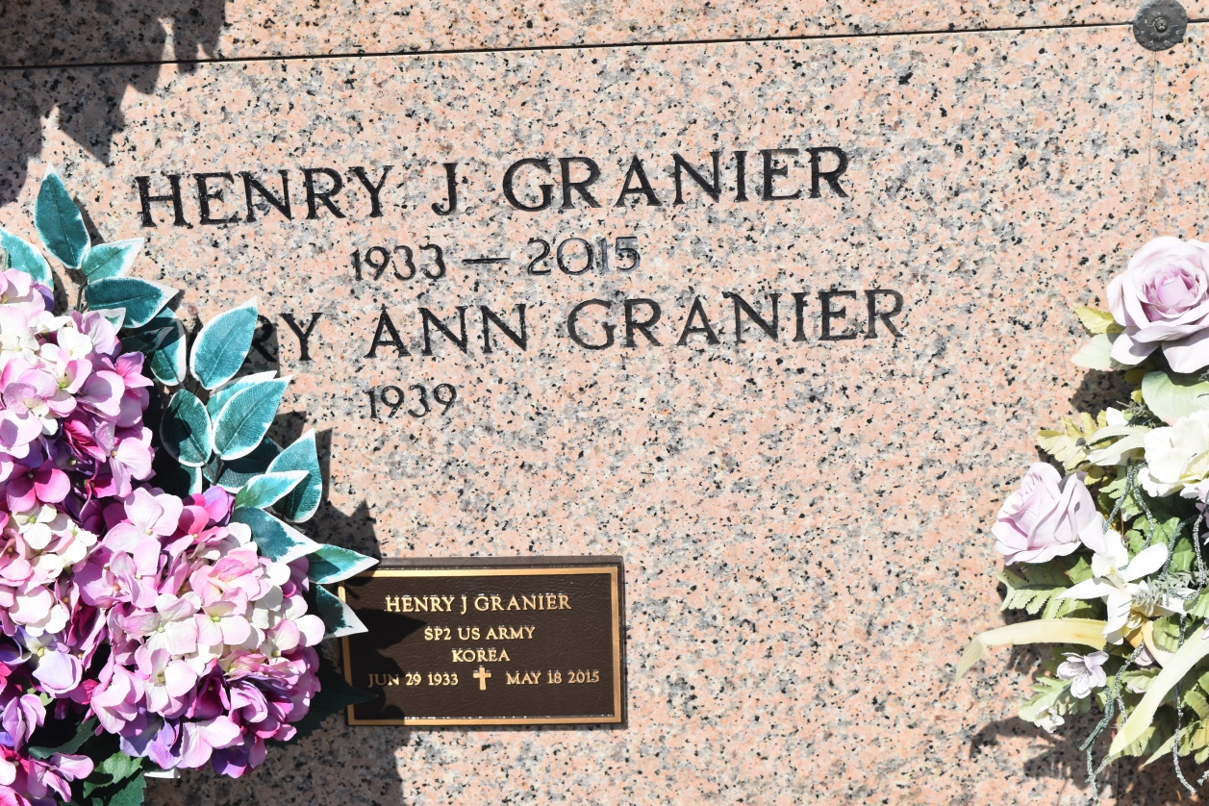

Henry J. Granier, 81, a native of Wallace, La. and a resident of Chackbay, La., passed away on May 18, 2015.  
 Visitation will be from 8:00 am until funeral time on Friday May 22, 2015 at Our Lady of Prompt Succor Catholic Church in Chackbay, LA. A Mass of Christian Burial will be celebrated at 10:30am at the church with burial at St. John the Baptist Cemetery in Edgard, La.  
 He is survived by his wife of 57 years, Mary Ann McCarthy Granier. He is the father of Anthony Granier and spouse, Yvette, Peggy G. Larousse and Fiance' Jason Zeringue; brother, Vernon Granier; sisters, Noelie Theriot and Lucille Cortez; 7 Grandchildren, 9 Great-Grandchildren.  
 He was preceded in death by his parents, Albin and Noelie Granier; brothers, Warren, A.J., and Arthur Granier; sisters, Rosalyn Hennan, Dorothy Ordoyne, Joyce Martinez, and Dollie Mae Cortez.  
 He was a veteran of the U.S. Army, retired from St. John the Baptist Parish and was a member of Woodmen of the World.  
 Thibodaux Funeral Home, Inc. is in charge of the funeral arrangements.

Times-Picayune, The (New Orleans, LA) - Wednesday, May 20, 2015

Contributed by Jane Edson