Elvire Theresa (Keller) Gravois

August 9, 1924 – December 8, 2001

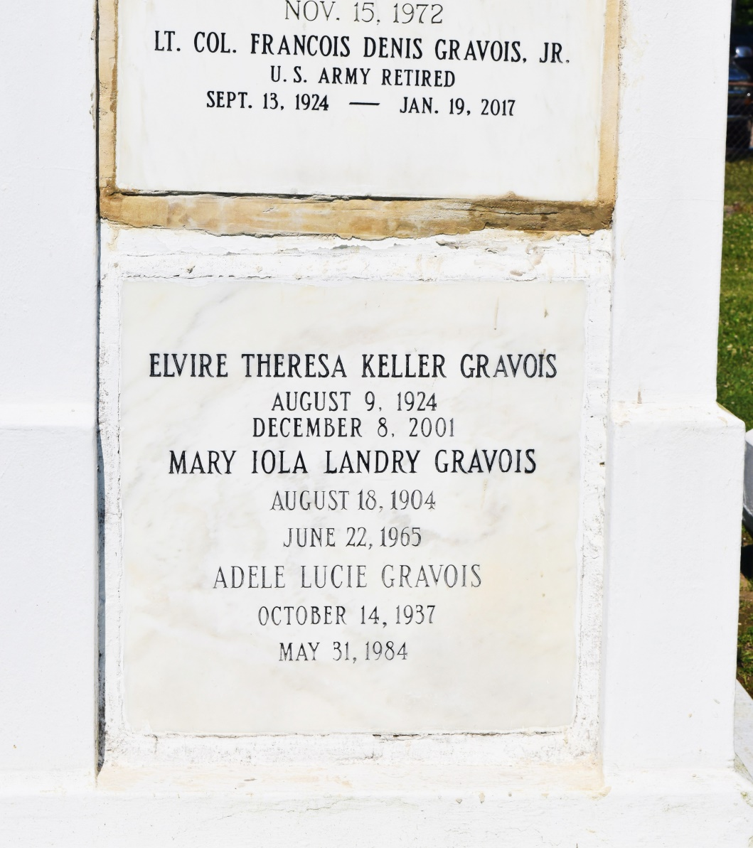 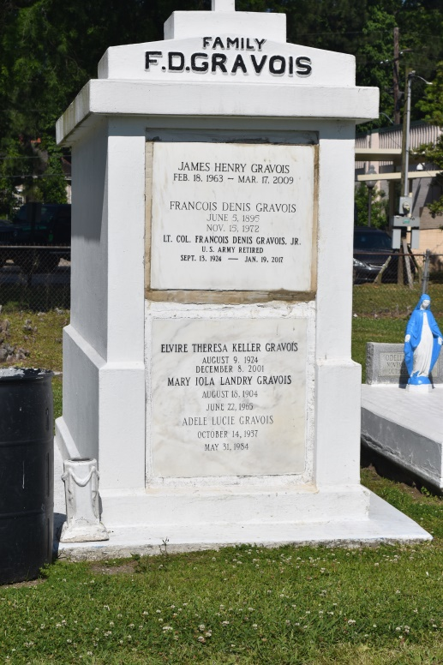

Bottom of Form

ALGIERS - Elvire Theresa "Ve" Keller Gravois, 77, a native of Hahnville and resident of Algiers for 32 years, died Dec. 8. She was the wife of Francois D. "Gravy" Gravois Jr. for 53 years and mother of Susan Baker, Francois III, Michael and James Gravois. She was the daughter of the late Theodore and Amanda LaBesque Keller and sister of Dorothy "Sis" Lirette, Theodore Jr. "Teddy" and Richard J. "Dick" Keller. She is also survived by three grandchildren. She was a U.S. Army wife for 20 years. Services were Dec. 11 at St. Andrew the Apostle Catholic Church, Algiers, with interment at St. John the Baptist Catholic Cemetery, Edgard.

L'Observateur, LaPlace, LA; Dec. 12, 2001