Francois Denis Gravois, Jr.

September 13, 1924 – January 19, 2017

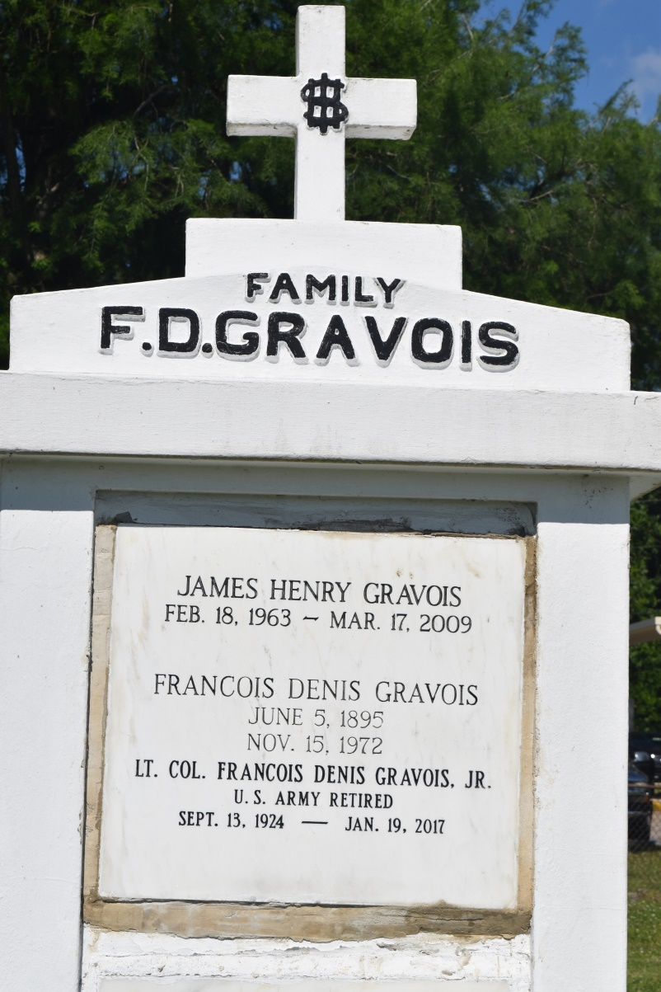

Lieutenant Colonel Francois Denis Gravois, Jr, (United States [Army](http://www.legacy.com/memorial-sites/army/?personid=183716296&affiliateID=3467), retired), also known as "Gravy" was born September 13,1924, and passed from this life January 19, 2017. F.D. was the oldest of eight children, born to Francois Denis Gravois and Iola Mae Landry Gravois in Saint Gabriel, LA. He grew up in Edgard, LA, and at 17 years old, joined the [United States Marine Corp](http://www.legacy.com/memorial-sites/marines/?personid=183716296&affiliateID=3467). He fought for his beloved country on four islands in the Pacific before being wounded, and was known for his courageous spirit and no nonsense character. Following the war, F.D. re-enlisted in the United States Army, and continued to serve his country until retirement in the rank of Lt. Colonel. F.D. spoke fondly and proudly of his military service throughout his life, and was honored to share his story with the [World War II](http://www.legacy.com/memorial-sites/ww2/?personid=183716296&affiliateID=3467) Museum in New Orleans, LA. Following military service, F.D. taught Business and Bookkeeping at Loyola University, and started his own business, General Business Services. For more than 30 years, he was an active volunteer, contributor, and Board Member for the YMCA of Greater New Orleans. F.D. was a faithful member and usher of St. Andrew the Apostle Catholic church, serving on their Finance Board, and as an officer in their Sages Senior Ministries. He was also active in the Knights of Columbus Council no. 9107. F.D. was preceded in death by his parents, and siblings Walter, Adele, Cynthia, and Jerome; wife of 54 years Elvire Keller-Gravois, son James Henry Gravois, and son-in-law Barry Baker. F.D. leaves behind his son, Francois D Gravois, III, "Frank", of Gretna, LA; daughter, Susan Gravois of Wilkes Barre, PA; and son Michael Gravois & wife Nora, of Georgetown, Texas. He was loved by his family and three grandchildren, Kaitlyn of Lubbock, TX; Thomas of New Orleans, and Gabrielle also of New Orleans, LA. His story telling, oyster eating, and fun loving presence will be missed by all, including siblings & spouses: Gloria & Ed Hicks of Lockport, LA; Maude & Jay Cheramie of Golden Meadow, LA; John Mire & Martha Gravois of Deland, FL; and countless extended family members. "Gravy", "F.D.", "Poppie", "Dad", or simply "Mr. Gravois" was a hero to many during different seasons in his life. He protected and provided for his siblings and family as a young man on the river; he was a hero for our country during World War II, Korea, and Vietnam; he served the greater New Orleans community in his volunteerism and leadership in the YMCA, and he was a devoted husband, father, grandfather, sibling, uncle, cousin, and in-law; Above all, he was a faithful follower of God. The family would like to acknowledge and personally thank all the staff and volunteers of "Hospice in His Care" and the Southeast Louisiana War Veterans Home for the compassionate care provided to "Mr. Gravy." Services for FD Gravois, Jr. will be conducted at the Mothe Funeral Home, 2100 Westbank Expressway, Harvey, La 70058 on Saturday January 28, 2017. Family visitation will be 11:00-12:00; Public Visitation 12:00-1:00; Funeral service and Mass to follow at 1:00 pm. Honorary pallbearers will be Frank Gravois (son), and Kaitlyn, Gabrielle, and Thomas Gravois (grandchildren). In lieu of flowers, donations may be made in honor of F.D. Gravois, Jr to the Southeast Louisiana War Veterans Home or the Greater New Orleans YMCA. Family and friends may view and sign the online guest book at [www.mothefunerals.com.](http://www.mothefunerals.com/)

Published in TheNewOrleansAdvocate.com from Jan. 25 to Jan. 28, 2017