James Henry Gravois

February 18, 1963 – March 17, 2009

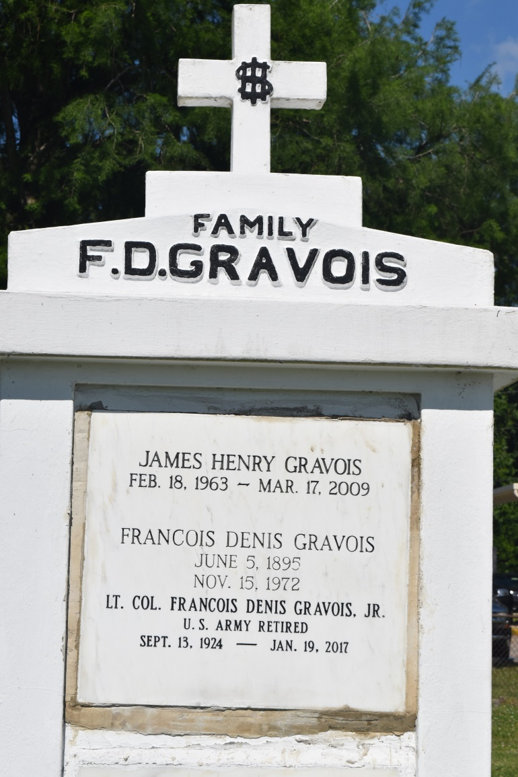

James Henry Gravois passed away on Tuesday, March 17, 2009 at the age of 46. He is survived by two children, Gabrielle and Thomas Gravois; father, F. D. Gravois, Jr.; two brothers, Frank and Michael Gravois and sister, Susan Baker.  
 A Memorial Mass will be held on Saturday, March 21, 2009 at 11:00 a.m. at Holy Spirit Catholic Church, 6201 Stratford Place, Algiers, LA 70131.  
 In lieu of flowers, please send contributions to Hickory Knoll Church of Christ, 2201 Hickory Ave., Harahan, LA 70123.  
 Richardson Funeral Home of Jefferson in charge of arrangements.

Times-Picayune, The (New Orleans, LA) - Saturday, March 21, 2009

Contributed by Jane Edson