Juanita Mary (Wilson) Grimes

February 1, 1938 – abt. January 10, 2018

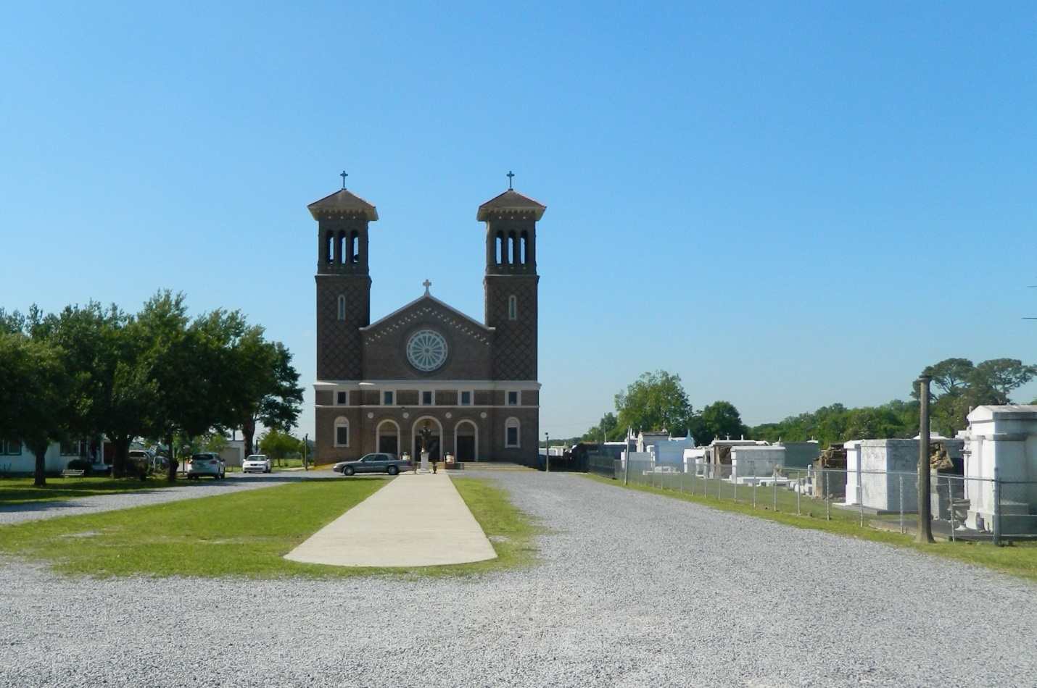

Juanita Wilson Grimes was born February 1, 1938 to the late Etienne and Elnora Wilson. Wife of the late Leonard Grimes Jr.; Sister of the late Martha Davis, Wilbert Wilson and Jackie Wilson. Grandmother of the late Matthew Grimes and great grandmother of the late Da'Nayshia Bloomer. She leaves to mourn one sister, Maldine Dilbert, six children; Leonard Grimes III, Sybil Grimes, Monica Grimes, Rodney Grimes, Charlene Whitespoon and Kathleen Downcercaux. She lived long enough to see seven grandchildren and ten great grandchildren born. Juanita graduated from Second Ward High School, Edgard, LA, in 1958. She then moved to New Orleans where she met her husband, Leonard Grimes and attended Mater DoLorosa Catholic Church in New Orleans. Juanita was a hard worker and loving person. She always put her family first and was a person that loved to cook and have a good time. She would open her house to anyone that needed a place to stay. Juanita resided in New Orleans until 2005 when hurricane Katrina forced her to move to Shreveport, LA to live with her daughter Kathleen. While living in Shreveport, she attended St. Mary of the Pines Catholic Church. After becoming ill, Juanita became a resident of Southern Hill Rehabilitation Nursing home where she lived until God called her home. A Mass of Christian Burial will be held on Saturday, January 13, 2018 from St. John the Baptist Catholic Church, 2349 Hwy 18, Edgard, LA 70049, Father Robustiano Morgia, Celebrant. Viewing begins at 10:00am followed by service at 11:00am. Interment in church cemetery. Treasures of Life Funeral Services, 315 E. Airline Hwy, Gramercy, LA 70052, have been entrusted with her final care. 225-258-4039.

www.treasurefunerals.com

(accessed 10/7/2018)