Emile Accomando

November 29, 1920 – June 5, 2010

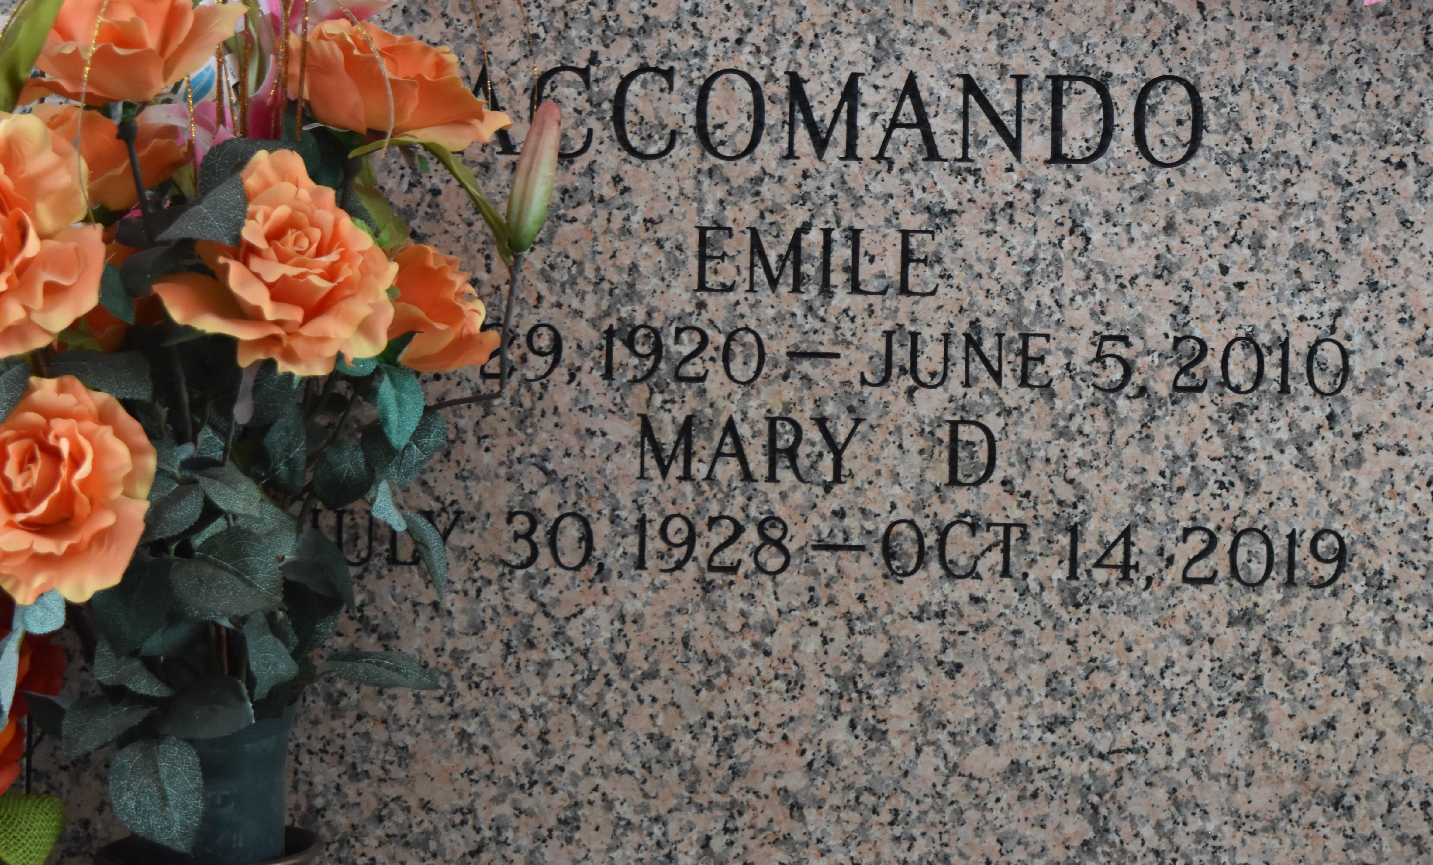

Emile Accomando passed away on Saturday, June 5, 2010. Beloved husband of Mary Dottolo Accomando. Father of Patricia McCarron and Keith Accomando. Grandfather of Jamie, Christina, and Matthew Accomando and Shaun McCarron. Great-grandfather of Kayley and Bethany. Age 89. A native of Hammond and a resident of LaPlace, La.

Relatives and friends are invited to attend services. Visitation at Millet-Guidry Funeral Home, 2806 W. Airline Hwy., LaPlace, La., on Tuesday, June 8, 2010 from 9:00 AM until 11:00 AM. Followed by a Mass at the Funeral Home Chapel at 11:00 AM. Burial on St. John Memorial Gardens Cemetery, LaPlace.

Times-Picayune, The (New Orleans, LA) - Sunday, June 6, 2010

Contributed by Jane Edson