Deborah A. Acosta
September 3, 1953 – March 6, 2001

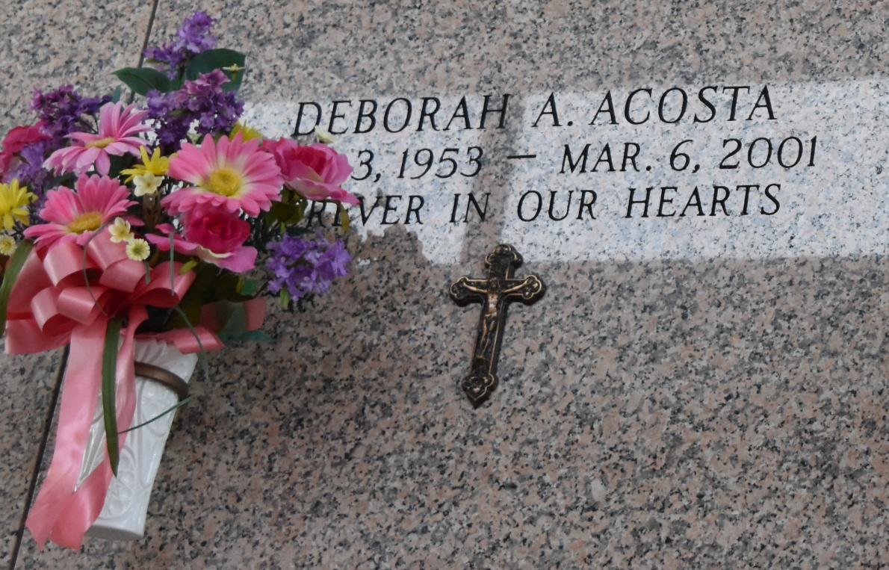

Debbie A. Acosta, 47, a native and resident of LaPlace, died March 6.
She was the mother of Denise Trosclair. She was also the daughter of the late Robert Acosta and Bernice Monaret, stepdaughter of the late Roland Monaret and sister of Chad and R.J. Acosta. She is also survived by one grandchild.
Services were March 9 in the chapel of Millet-Guidry Funeral Home, LaPlace, with interment at St. John Memorial Gardens, LaPlace.
L'Observateur, LaPlace, Louisiana
March 10, 2001

