Kyle Jude Acosta

January 28, 1971 – January 3, 2006

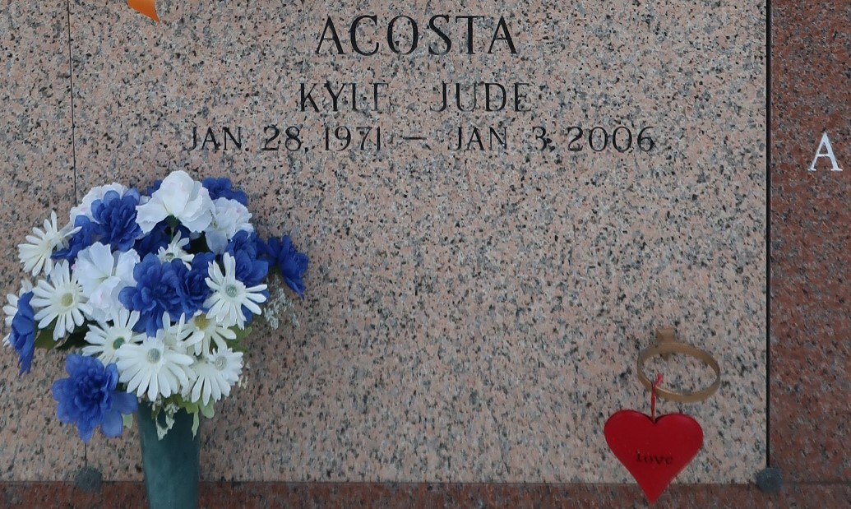

LAPLACE - Kyle Jude Acosta, 34, a native of LaPlace and a resident of Prairieville, died Jan. 3. He was the husband of Jennifer Mabrey Acosta. He is survived by his children Elijah and Olivia Acosta.He is also survived by his mother Lynne Laiche Acosta and siblings Bret Acosta, Ann Engnath and Joel Baer.  
 He was preceded in death by his father Ronald Acosta and grandparents Luciana and Joseph Acosta and Altheanne and Lawrence "Squint" Laiche Sr.  
 Services were held Jan. 6 at St. Joan of Arc Catholic Church, Laplace, with interment in St. John Memorial Gardens, LaPlace.

L'Observateur (La Place, LA)

Monday, January 9, 2006

Contributed by Jane Edson