Taylor Nicole Adams

June 22, 1995 – December 5, 2010

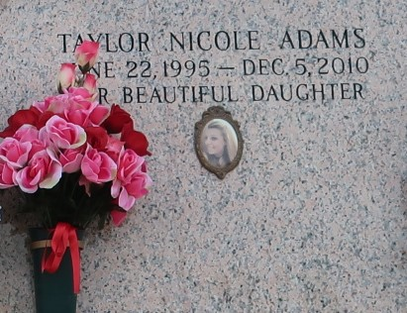

Taylor Nicole Adams, 15, a native and resident of LaPlace, passed away Sunday, Dec. 5, 2010. She was the beloved daughter of Gaylyn Gendron Adams and Edward Adams; granddaughter of Robert Gendron Jr. and the late Sarah Rollo Gendron and Teddy and Virginia Adams; niece of Darlene Keyser, Joseph Spain, Robin and James Vicknair, Bryan Gendron and Jeri Verdin; and cousin of Heidi, Jayme and Brittany Vicknair, Benjamin Gendron, Andrew and Nathan Verdin and Hannah St. Martin. She is also survived by many friends.

Relatives and friends are invited to attend services. Visitation is at Millet-Guidry Funeral Home, 2806 W. Airline Hwy., LaPlace today, Saturday, Dec. 11, from 8 a.m. until 10 a.m., followed by a religious service at the funeral home chapel at 10 a.m. Burial will be in St. John Memorial Gardens, LaPlace.

L'Observateur (La Place, LA) - Saturday, December 11, 2010

Contributed by Jane Edson