Troy Vincent Allen Sr.

January 19, 1970 – December 15, 2013

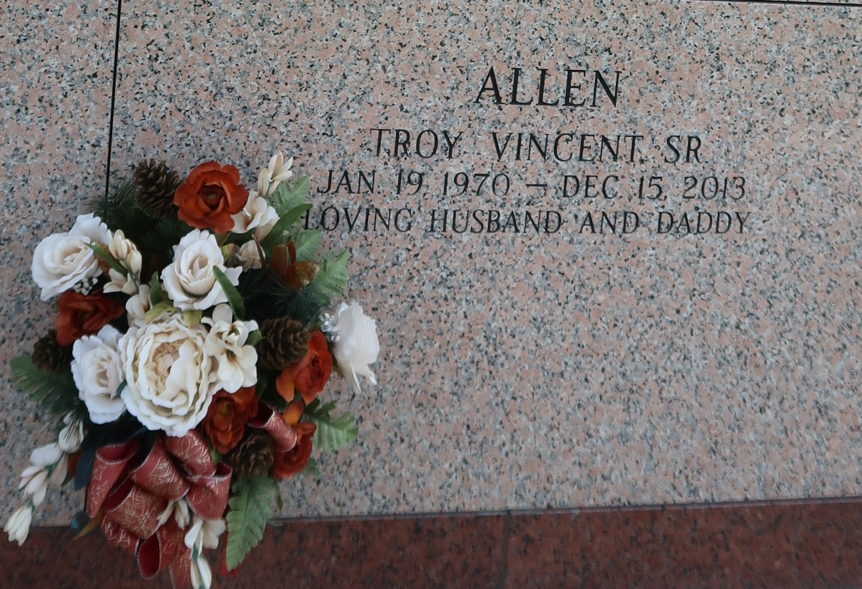

Troy Vincent Allen of Gramercy, LA on Sunday, December 15, 2013, at Ochsner Hospital entered into eternal rest, age 43 yrs. He is preceded in death by his grandparents, Thomas and Celestine Allen and Newton and Aldonia Batiste and one aunt Deborah Batiste, three uncles Thomas Allen, Jr., Ernest Harris, and August Batiste.

He leaves to cherish his memories his wife Nikita Allen and their four children Troy, Jr., Nia, Nya, and Ashley. His parents, Washington and Senobia Allen, his sister Rhonda Young (Mario), and nephew Mario Young, Jr., his mother and father-in-law Willard and Margie Standberry, his sister and brother-in-law Eric and Yolanda Brown and their son, Austin. Also survived by a host of aunts, uncles, other relatives and friends.

Relatives and friends of the family, also pastors, officers, and members of First Community Antioch Baptist Church, Second African Baptist Church, St. Phillip Catholic Church, and all neighboring churches, employees of Motiva Enterprise, and South Central LA. Technical College are invited to attend the funeral services on Saturday, December 21, 2013 at 11:00a.m. at First Community Antioch Baptist Church of Gramercy, LA. Rev. Ferdinand Gaines, Jr. officiating. Interment in St. John Memorial Garden of LaPlace, LA. There will be a viewing at the above named church on Friday, December 20, 2013, from 4:00p.m. to 7:00p.m. Bardell's Mortuary of Mt. Airy, LA in charge. Information: 985-535-6837

Times-Picayune, The (New Orleans, LA) - Friday, December 20, 2013 Contributed by Jane Edson