Jacqueline Anderson

September 14, 1946 – July 8, 2015

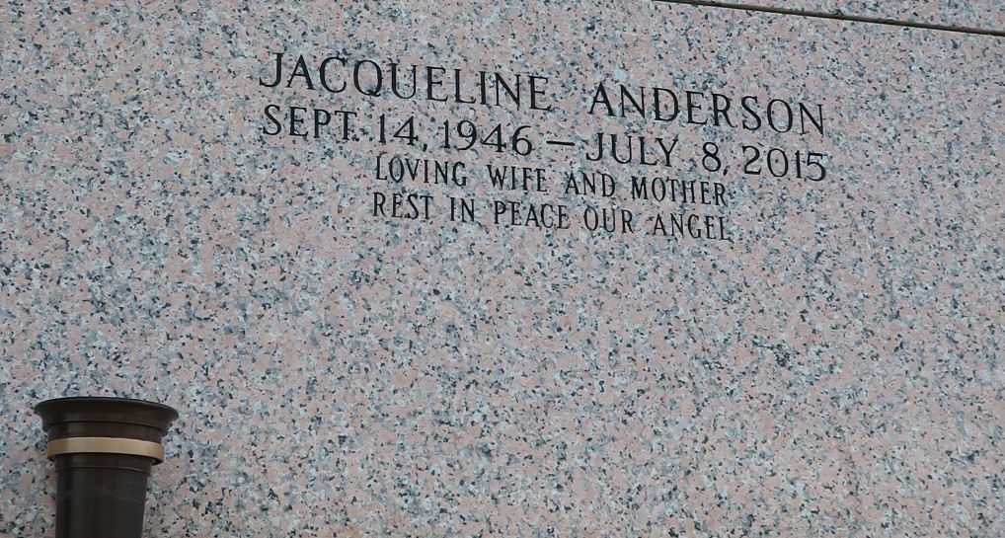

Jacqueline "Jackie" Anderson passed on July 8, 2015. Wife of Cleveland Anderson. Mother of Jerome Tanner, Cleveland and Byron Anderson, Uchenna and Nicole Williams; Stepmother of Rochelle Lassere and Georgiana Anderson. Survived by (5) grandchildren, (1) brother, (2) sisters and a host of other relatives and friends.

Funeral service on Wednesday, July 15, 2015 at Riverlands Christian Center, 123 Redemption Way, Reserve, LA at 11:00am. Visitation at 9:00 am until service time. Rev. Steven Perrilloux Pastor officiating. Internment St. John Memorial Garden, Laplace, LA. Service Entrusted to Hobson Brown Funeral Home, Garyville, La 70051 985-535-2516

Times-Picayune, The (New Orleans, LA) - Sunday, July 12, 2015 Contributed by Jane Edson