Joey Anderson

September 14, 1946 – July 8, 2015

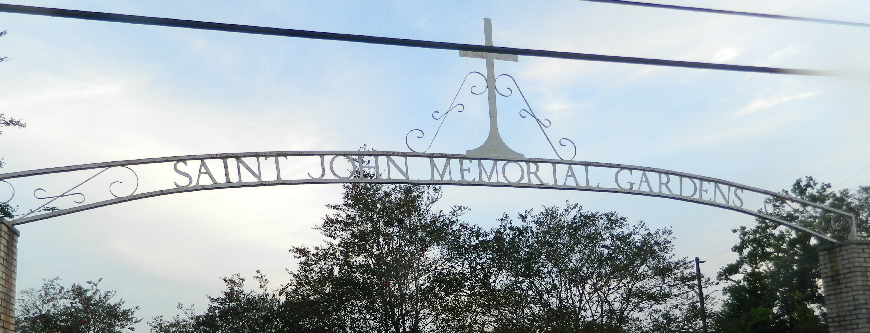

Joey Anderson on Friday, May 19, 2017 at Twin Oaks Nursing Home, LaPlace, LA. Son of the late Freddie Anderson and Felice Anderson Brown. Stepson of the late Johnny Brown. Father of Joey Anderson, Jr. Brother of Octarve Anderson, Freddie Lee Brown, Randolph Anderson, Anita Clement, Clayton Anderson, Elise Perrilloux, Brenda Exxum, the late Mary Ann Parquet, Audrey Wilson, Sylvia, Larry and Danny Anderson. Also survived by a host of nieces, nephews, other relatives and friends. Age 63 years. A native and a resident of LaPlace, LA.

Relatives and friends of the family, also priest and parishioners of Our Lady of Grace Catholic Church and all neighboring churches are invited to attend the Funeral Mass at Our Lady of Grace Catholic Church, 772 Highway 44, Reserve, LA on Friday, May 26, 2017 at 10:00 AM. Interment St John Memorial Garden Cemetery, LaPlace, LA. Visitation at the above named church from 8:15 AM until Mass time. Rosary at 9:15 AM SERVICED BY ROBOTTOM

Times-Picayune, The (New Orleans, LA) - Monday, May 22, 2017

Contributed by Jane Edson