Nolan Anderson Sr.

August 1, 1964 – September 24, 2014

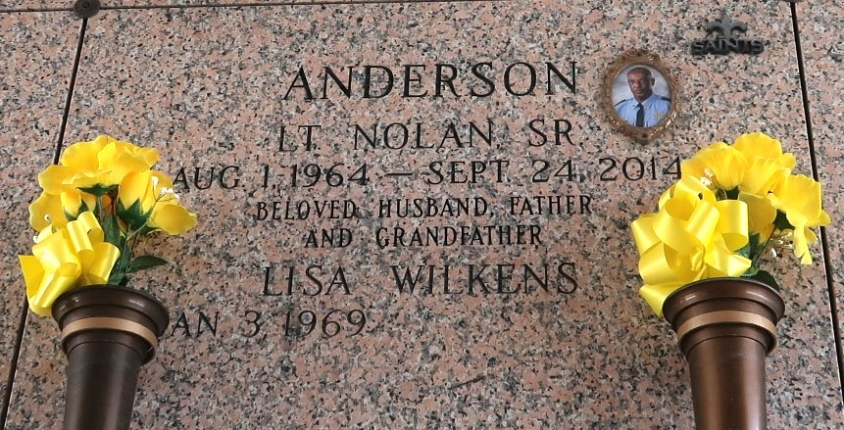

Lt. Nolan "Too Till" Anderson, Sr. a native of Laplace, LA. entered unto eternal rest on Wednesday, September 24, 2014 at the age of 50. He was the loving son of the late Merdell & Lawrence Anderson, Sr. Nolan was educated in St. John School system. He loved and cherished his job at the St. John Sheriff department, where he served as a Lieutenant. He was the longtime companion of Lisa Wilkens Anderson.

Nolan leaves to cherish his memories five children: Shondrika, Nolandra, Aaliyah and Nolan Anderson, Jr. and Dominique Graham, eight brothers: Lawrence, Jr., Ernest, Ronald and Micheal Anderson, Darnell and Jermaine Jolla, Brian and Clint Langford four sisters: Roxanne and Valerie Anderson, Veronica Cloudet and Sylvia McDonald, stepmother, Linda Anderson, grandmother, Mildred Narcisse, mother-in -law, Mary J. Branch and a host of other relatives and friends.

Relatives and friends of the family, parishioners of The New Rescue Mission B.C, Southern LA War Veteran Home, Home Depot and the St. John Sheriff Office are invited to attend the Funeral Service at the New Wine Christian Center, Laplace, LA. on Saturday, October 4, 2014 at 11:00 a.m. Visitation will begin at 9:00 am to10:45 am. Interment will follow at the St. John Memorial Garden. Arrangements by Heritage Funeral Directors (504) 944-5500. Directors, Carmen and Shelia Baloney.

Published by The New Orleans Advocate from Oct. 2 to Oct. 4, 2014.