Yolanda R. (Hood) Anderson

May 25, 1973 – September 20, 2019

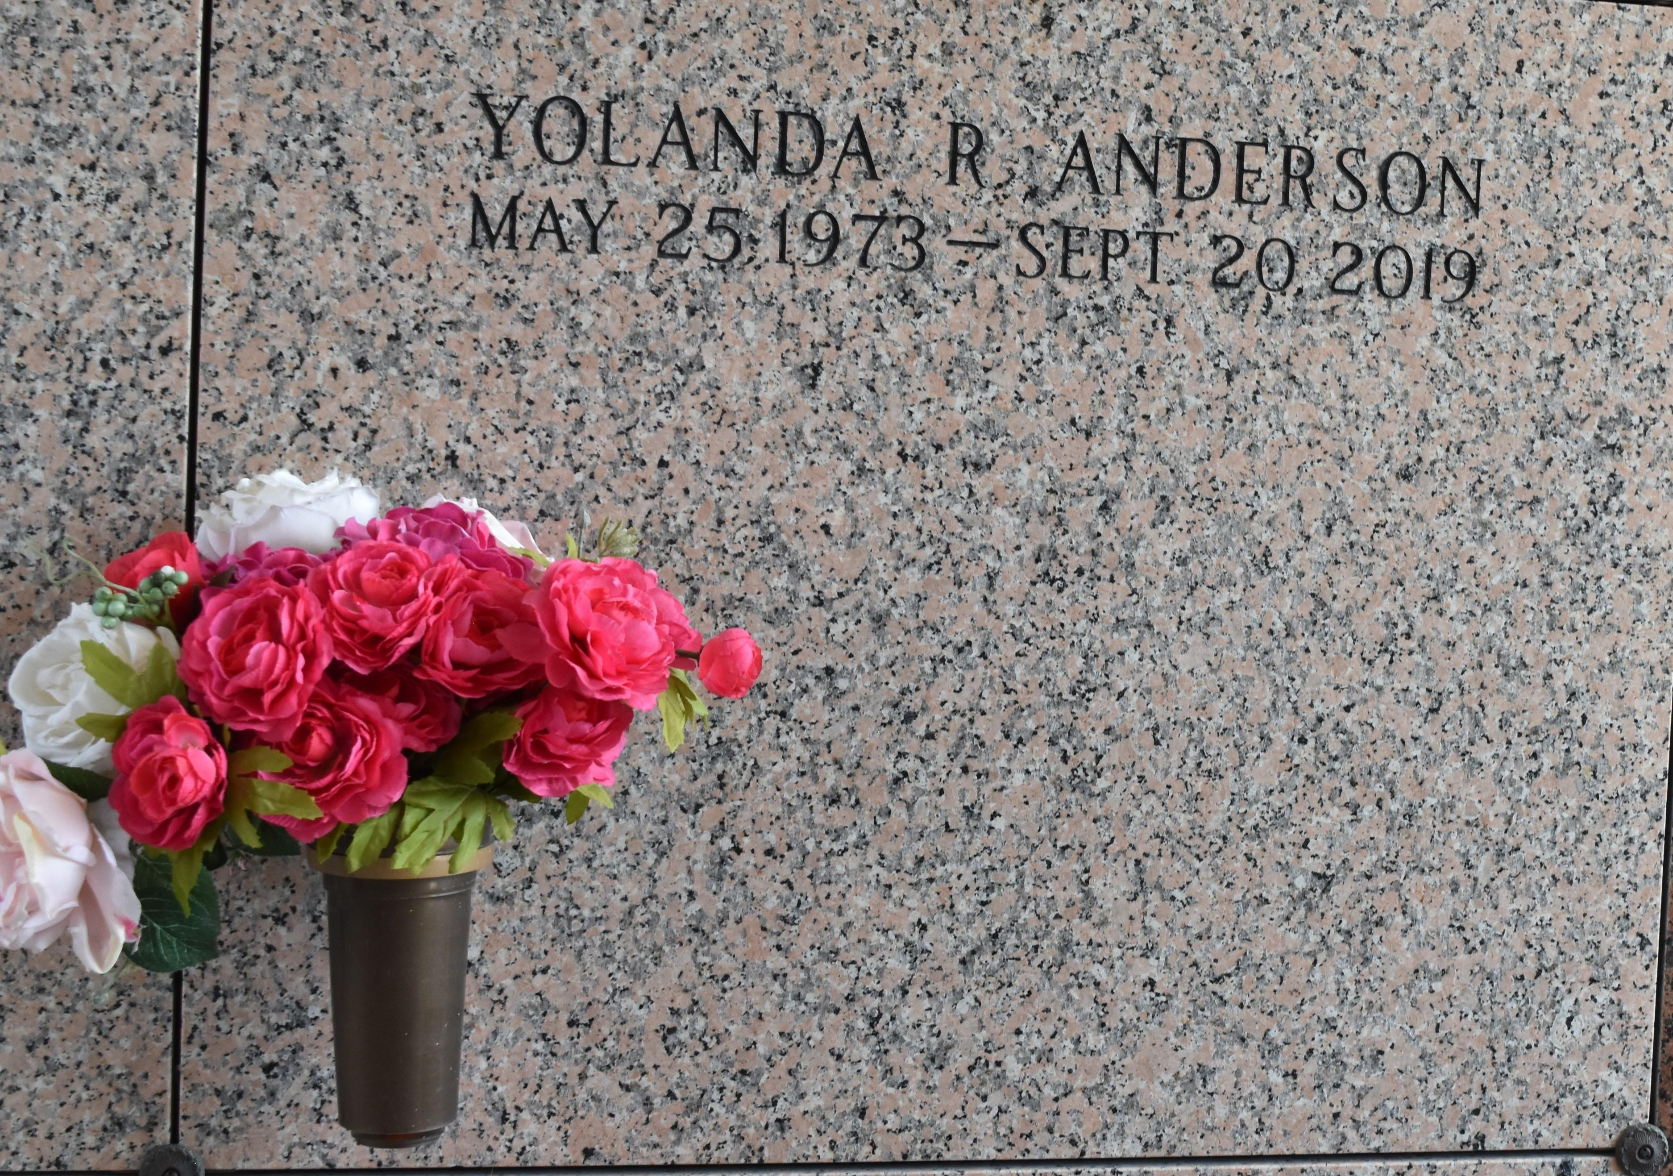

Yolanda R. Anderson, age 46, departed this life on Friday, September 20, 2019. Daughter of Denise Richardson and Tommy Hood; Wife of Armond Anderson; Mother of Elantra Richardson and Jaire Anderson; Grandmother of Chaze Butler; Sister of Keyon Richardson; Daughter in law of Garry and Debra Anderson; Niece of Maxine Richardson, Lydia Johnson, Marie and Amelia Coates. Yolanda is also survived by other relatives and friends. Funeral Service will be held on Saturday, October 5, 2019 at Milesville Memorial Church of God in Christ, 129 Apple St. Laplace, LA at 10:00 am. Bishop Ronald Frank, Pastor, Officiating. Visitation on Friday, October 4, 2019 at the above-named church from 5:30 pm until 7 pm and on Saturday at 8 am until service time (ONLY). Interment: St. John Memorial Garden, LaPlace, LA. Professional Services entrusted to the caring staff of Hobson Brown Funeral Home, 134 Daisy St, Garyville, La 70051. 985-535-2516

Published in The Times-Picayune (New Orleans, LA) on Oct. 4, 2019