Kathleen (Madere) Andry

February 24, 1944 – October 6, 2015

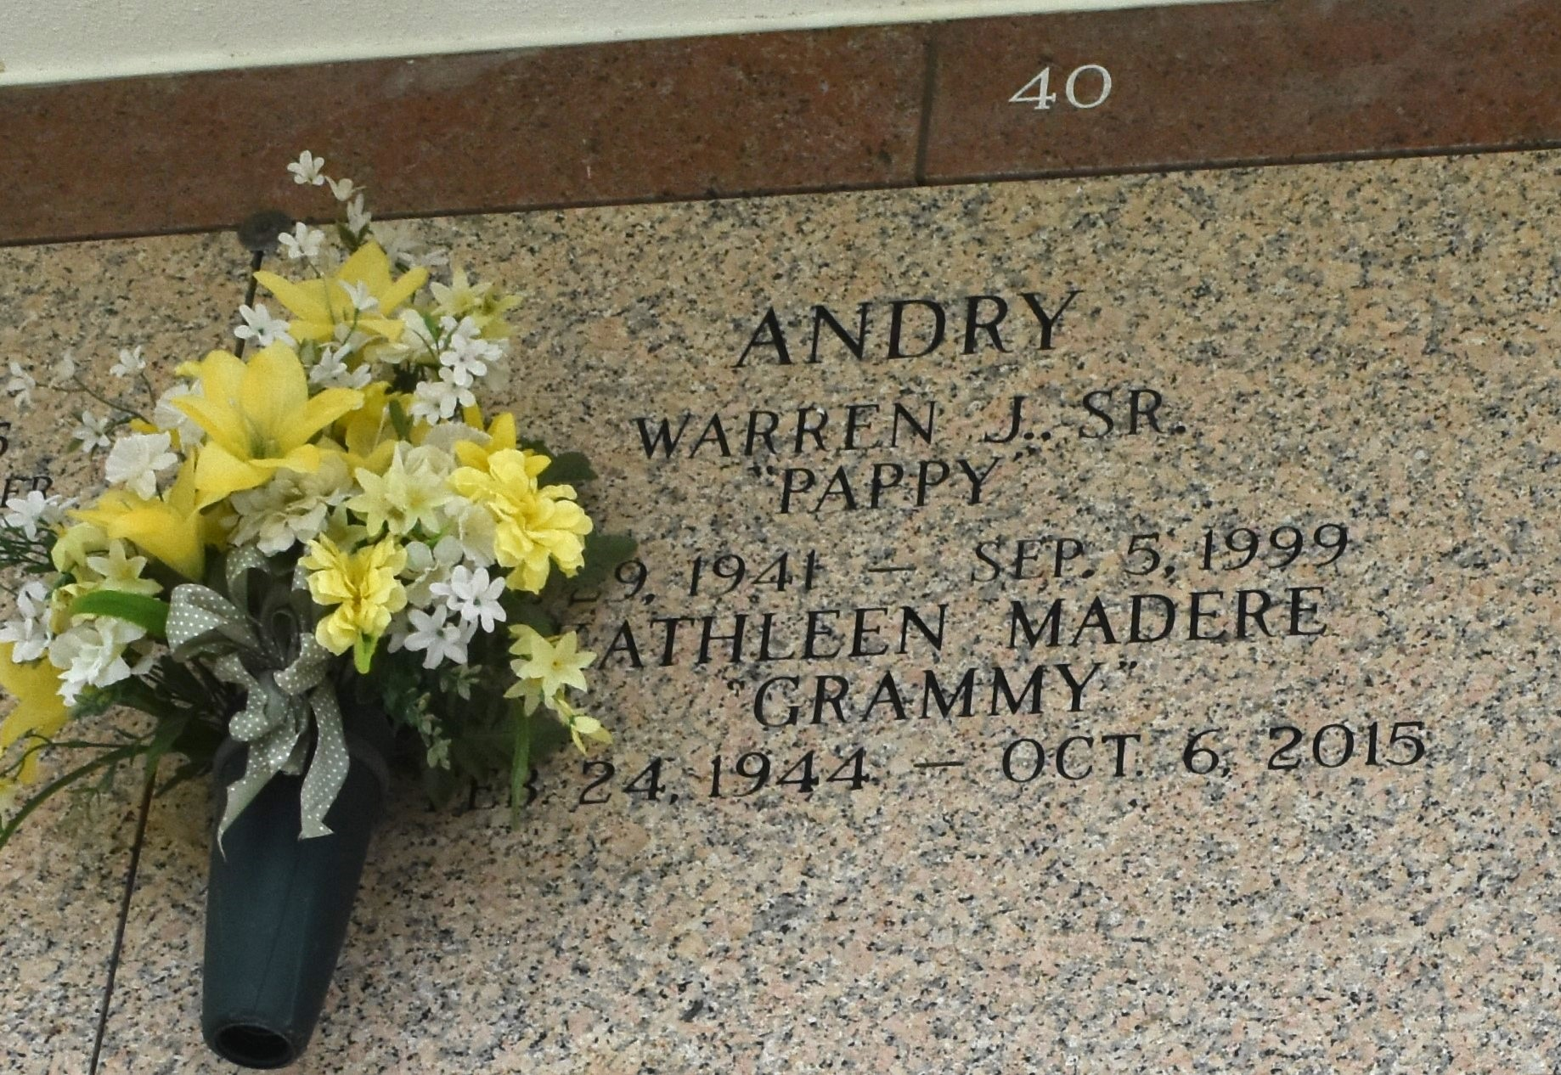

Kathleen Madere Andry passed away on Tuesday, October 6, 2015 at the age of 71. She was a native of New Orleans and a lifelong resident of LaPlace. Beloved wife of the late Warren J. Andry, Sr. Loving mother of Warren J. Andry, Jr. (Wendy), Samuel Andry (Monica), Stephen Andry (Linda), Jeanine Vicknair (Pascal), Stuart Andry and Heather Lozano (Mikey). Grandmother of Warren Andry, III, Gabrielle Andry, Lacey Vicknair, Alicia Vicknair, Brittany Andry, Cory Andry, Cody Andry, Jolie Lozano, Emma Lozano, Mikey Lozano and Madison Lozano. She was predeceased by her parents, Violet Mae Villmont and Davis Roger Madere, Sr. Sister of Davis Roger Madere, Jr. and the late Samuel Earl Madere. Relatives and friends are invited to attend the Funeral Mass at St. Joan of Arc Catholic Church, 529 W. 5th St., LaPlace on Thursday, October 8, 2015 at 12:00 p.m. Visitation will begin in the church at 10:00 a.m. Interment in St. John Memorial Gardens Cemetery. Arrangements by Millet-Guidry Funeral Home. To view or sign the online guestbook please visit www.milletguidry.com

Times-Picayune, The (New Orleans, LA) - Wednesday, October 7, 2015 Contributed by Jane Edson