Carrie Lee (Wilkens) Anthony

August 1, 1945 – May 25, 2009

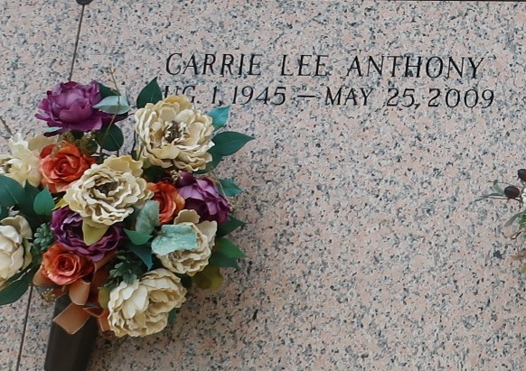

Carrie Lee Anthony departed this earthly life and entered into eternal rest on Monday, May 25, 2009 at River Parish Hospital of LaPlace, LA. Daughter of the late Hazel and Lawrence Wilkens, Sr. Beloved mother of Nina (Corey) Vinnette of St. Rose, LA and Derek Anthony of LaPlace, LA. Loving grandmother of Sean (Crystal) Stewart and David Stewart, Ivy and Ivan Anthony. Greatgrandmother of Zion and Raeshawn Stewart. Sister of Clay (Margie) Wilkens, Clarence (Goldie) Wilkens, the late Ernest and Lawrence Wilkens, Jr. Also survived by a host of aunts, uncles, nieces, nephews, other relatives and friends. A resident of LaPlace, LA. Age 63 years. Relatives and friends of the family; also pastors, officers and members of Rising Star Baptist Church of LaPlace, LA, all neighboring churches; and employees of St. John Parish Schools are invited to attend the Funeral Services on Saturday, May 30, 2009 at 11:00 a.m. at the Rising Star Baptist Church, 620 Cardinal St., LaPlace, LA. Rev. Donald August, officiating. Interment in St. John Memorial Garden, LaPlace, LA with ascending doves symbolizing the commending of the departed soul. Visitation will be at the above named church from 9:00 a.m. until service time. Bardell's Mortuary of Mt. Airy, LA in charge. Information: (985) 535-6837.

Times-Picayune, The (New Orleans, LA) - Friday, May 29, 2009

Contributed by Jane Edson