Todd J. Arceneaux

May 27, 1965 – October 17, 2008

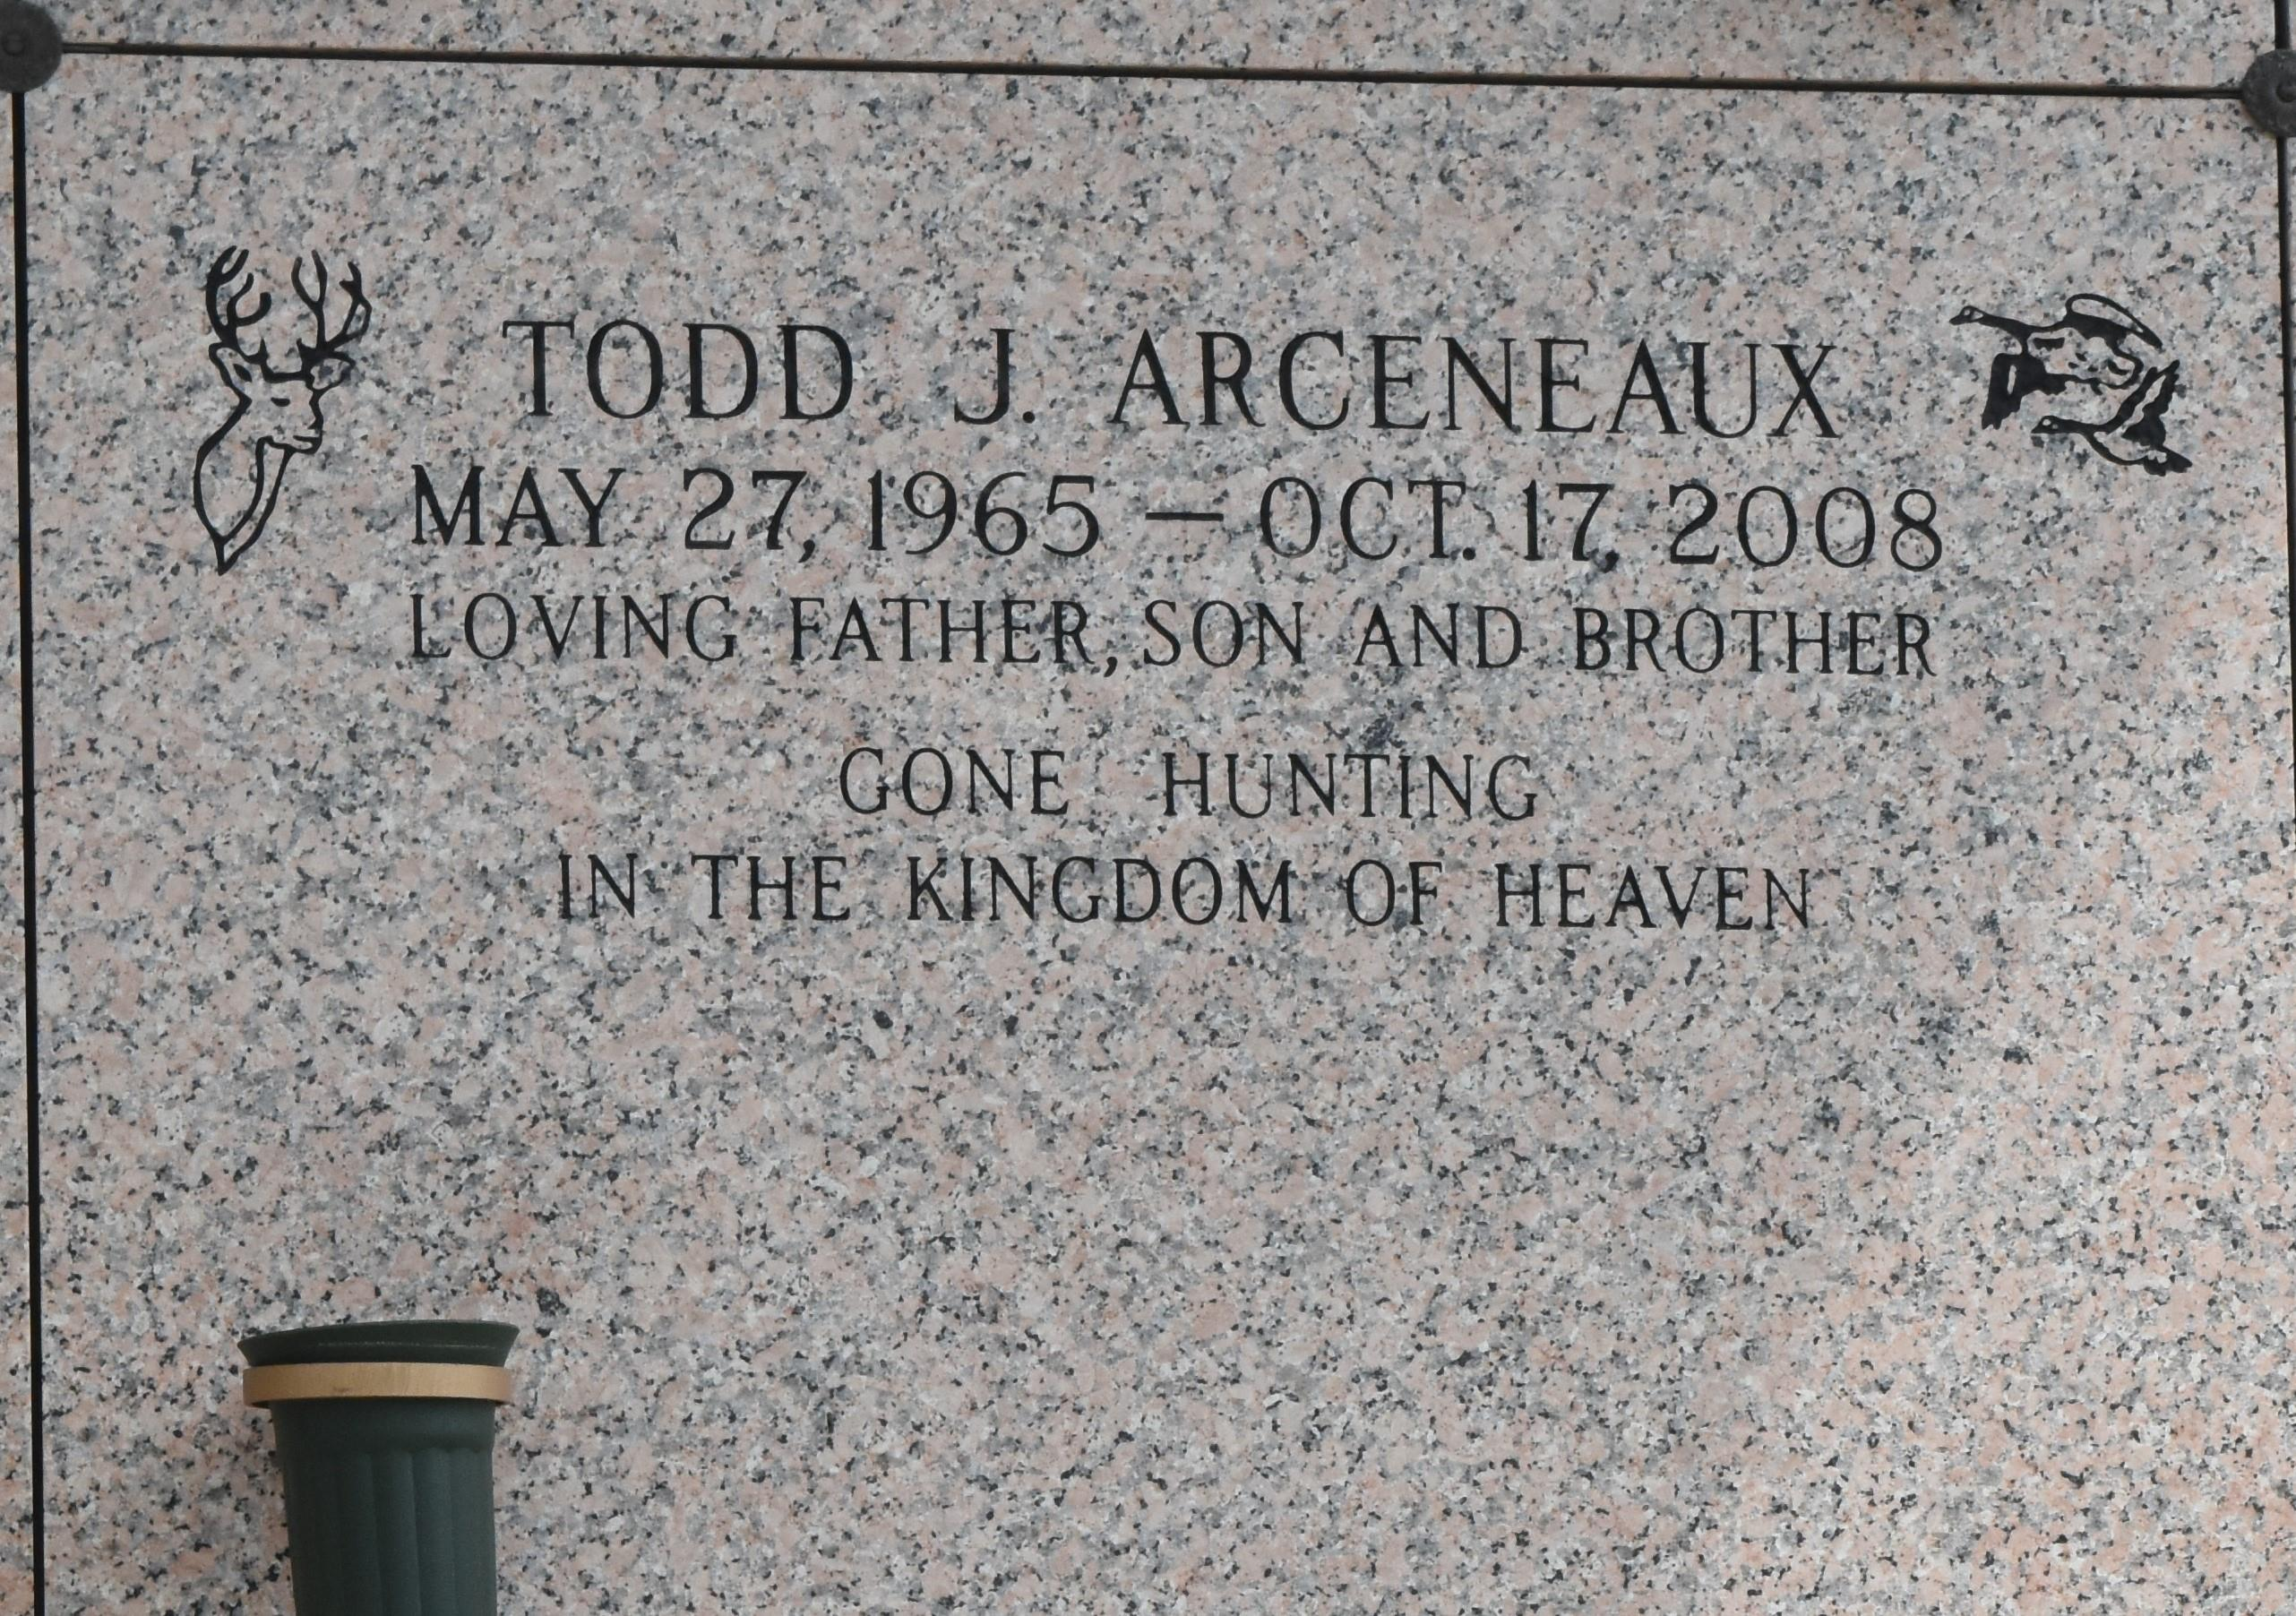

Todd J. Arceneaux on Friday October 17, 2008 at 1:45 p.m. Beloved father of Taylor, Trevor and Trey Arceneaux. Son of Delton and Sue Arceneaux. Brother of Tanya St. Pierre, Toni Clay, Terri Braud, Ted Arceneaux and Tami Levatino. Age 43. A native and resident of LaPlace, La.

Relatives and friends are invited to attend services. Visitation at Millet-Guidry Funeral Home, 2806 W. Airline Hwy., LaPlace, La. on Monday October 20, 2008 from 5:00 p.m. to 9:00 p.m. and on Tuesday from 8:00 a.m. to 9:45 a.m. Followed by Religious Services at St. Joan of Arc Catholic Church, LaPlace at 10:00 a.m. Burial in St. John Memorial Gardens Cemetery, LaPlace, La.

Published by The Times-Picayune, New Orleans, Louisiana on Oct. 19, 2008.