Carol (Dillon) Armant
March 8, 1941 – June 12, 2024

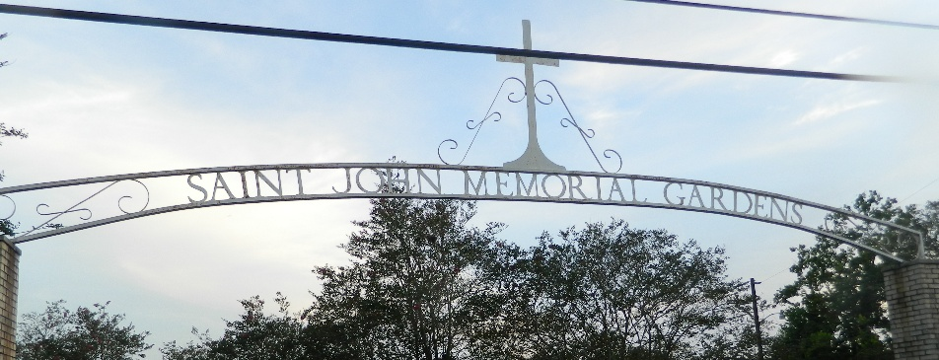

Carol Dillon Armant, affectionately known as “Jimmy”, “Gram”, “Mother”, “Two”, and “Caldonia”, entered into her eternal life on Wednesday, June12, 2024, at the age of 83. Carol was born on March 8, 1941 to the late Louis and Leotha Dillon. Carol was united in Holy Matrimony to the late Norbert Armant on November 26, 1960.
LOVING MOTHER To this union four children were born: Wilhelmina Marie (Michael) Clayton, Daphney Fluence, Sonja (Leroy) Mitchell, all of Laplace, La. and Thaddues Armant of Metairie, La. She was also a mother to Aaron Lewis of Gonzales, La., Bianca Davis, and Denise (Milton) Smith of Laplace, La.
THOSE WHO CALLED HER “GRAM” Carol was the grandmother of six grandchildren: Tasia Clayton, Tiesha (Tony) Gales, Ronald Lathers, Jr., Deshaud (Darnisha) Fluence, D'Jante Armant and Zaki Mitchell. She had 15 Great Grand Children: Tyler, Chloe, Taylor, Taylin, Trinity, Ramone, Brison, Jeremiah, Remi, Kholbi, Tru, Legynd, Prime, Dre'Dain, and Na'Vaj. She was a God-mother to Acquanette Markey, Ernest Williams, Jr. and Maria Populis.
LOVING SISTER She was the loving sister to Donna Webb of San Francisco CA, Pastor Warren Dillon(Aleen), Alvin (Chandra) Dillon of Atlanta GA.
PERSEVERANCE OF WOMAN, CAROL’S STORY Carol was baptized at an early age at The First Baptist Church in Vacherie, La. by the late Reverend Arthur Jones. Her favorite scripture was Psalms 23. Carol was educated in the St. James Parish School System. After graduating, she met the love of her life and were married at the age of 26 years old. She experienced a tragic loss, when the love of her life, Norbert, was killed in a car accident. Leaving her to raise a five, four, and three years old while eight months pregnant with her fourth child. She was employed at the Waterford 3 nuclear plant in Taft. La. and Marathon Refinery of Garyville, La., where she worked for several years. Later, she pursued a career in the St. John Parish Public School System. She was employed at LaPlace Elementary as a cafeteria Technician. She later retired from the Glade Elementary.
DEVOTED FRIENDS AND FAMILY She was a devoted friend to Raymond Anderson, Jessie Jasmin, and Loretta Tassin. She leaves to cherish her memories a host of nieces, nephews, cousins, and other friends. SPECIAL BONDS Gram had a special bond with Jhayce (Jhaycee) Trench who she loved dearly.
PRECEDED IN DEATH by her husband Norbert Armant and parents Louis & Leotha Dillon. Siblings: Sarah Lewis, Audrey Harrison, Langford Anderson, Ronald Dillon, Yolanda Lemieux, Kathleen Batiste (her best friend/ sister) , and Oralee Duhe (her devoted cousin). One sister-in-law, Velma Dillon; three brothers- in- law, Donald Lemieux, Ronald Batiste, and Lawrence Harrison; nephews, Qualyn & Wayne Dillon, and Antonio Harrison. A celebration honoring her life and legacy will be held on Saturday, June 29, 2024 at Beech Grove Baptist Church, 117 Beech Grove Dr., Reserve, La 70084. Visitation period begins for 8am with service to follow for 10am.Final viewing prior to start of service. Pastor Cory Batiste officiating. Entombment St. John Memorial Gardens, 2205 W. Airline Hwy., Laplace, La. 70068.

Treasures of Life Funeral Services, Gramercy, Louisiana
July 4, 2024

