Lester Augustine
1966 – August 29, 2018

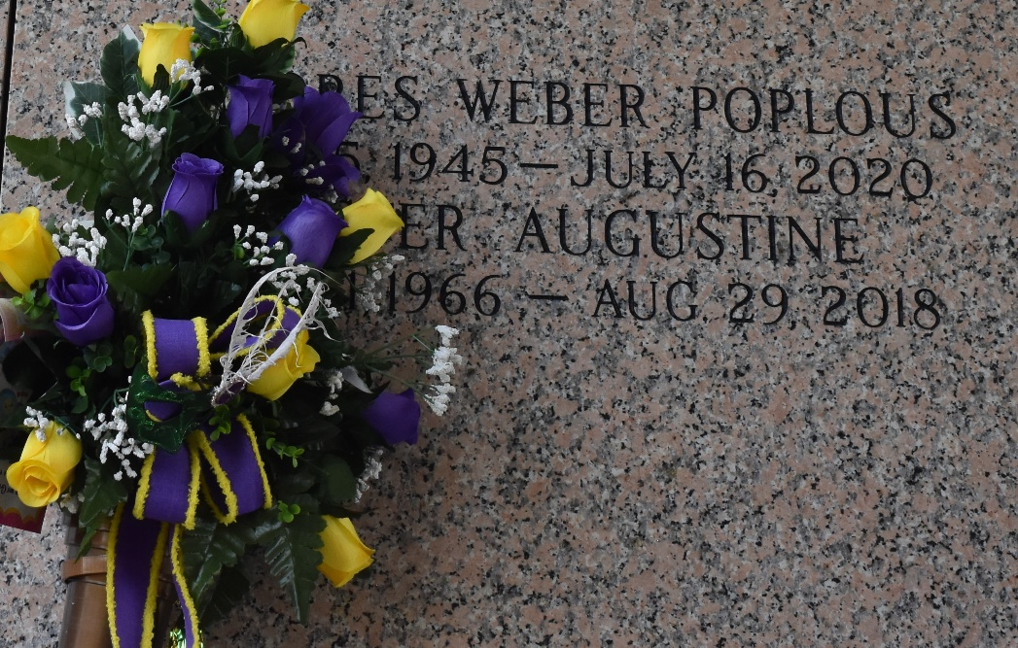

Lester Augustine, a 51-year-old black man, was shot and killed Wednesday, Aug. 29, near West 120th Street and Denver Avenue in Vermont Vista, according to Los Angeles County coroner’s records.
Shortly before 3 a.m., a person in the area heard gunshots and called police, who discovered Augustine wounded on the ground, said Los Angeles Police Det. Nathan Kouri. Augustine was pronounced dead at the scene at 3:12 a.m., according to coroner’s records.
Police are still trying to determine what happened in the moments preceding the shooting. Augustine was not a gang member and worked at Los Angeles International Airport, Kouri said. It’s unknown if the assailant drove by and shot at Augustine or walked up to him.
Anyone with information is asked to call detectives at (323) 786-5111. Those who wish to remain anonymous can call Crime Stoppers at (800) 222-8477.

Los Angeles Times: The Homicide Report, California
September 17, 2018

