Xiomara Waleska (Pavon) Ayala

March 26, 1985 – January 31, 2023

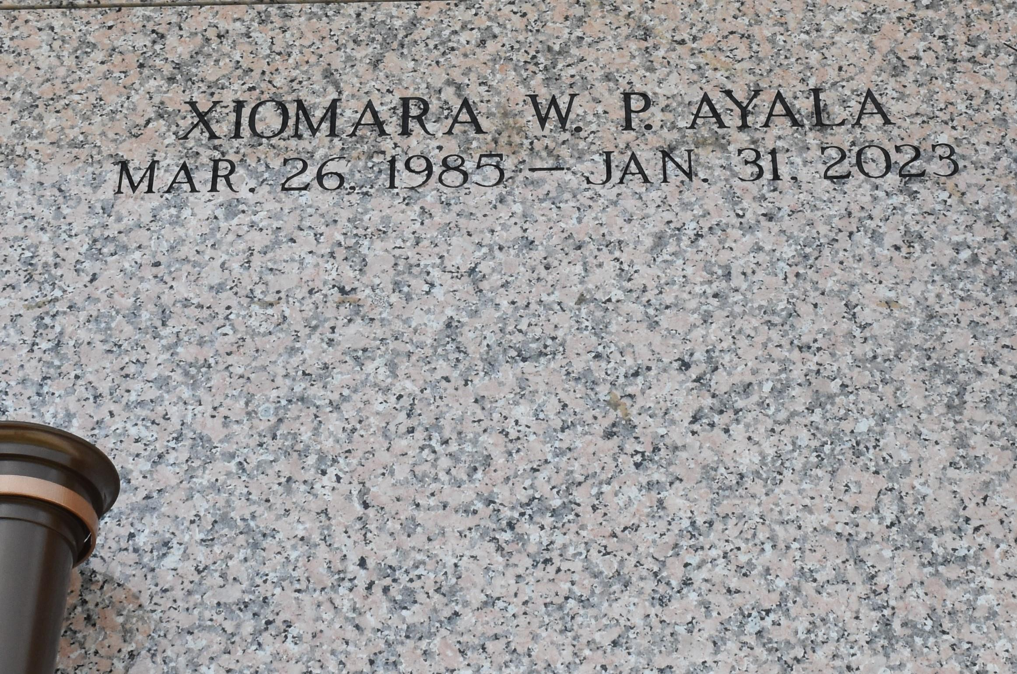

Xiomara Waleska Pavon Ayala passed away on Tuesday, January 31, 2023 at the age of 37. She was a native of Tela, Honduras and a resident of LaPlace, LA. Beloved mother of Angel Hernandez, Ilsa Hernandez, Daniel Hernandez, Duhans Pavon, Juan Carlos Mendez and Jimmy Pavon. Daughter of Maria Anastacia Ayala and the late Hector Josue Pavon. Sister of Karen Vargas (Hector Rivera, Sr.), Yosselyn Ayala and Brenda Ayala. Aunt of Josshua Rivera, Iracema Rivera, Hector M. Rivera, Jr., Sarai Salvador, Iracema Salvador, Elio Villatoro, Jonathan Villatoro, Zoila Villatoro and Eliana Villatoro.

Relatives and friends are invited to attend the Funeral Service on Thursday, February 9, 2023 at Millet-Guidry Funeral Home, 2806 W. Airline Hwy., LaPlace at 11:00 a.m. Visitation from 9:00 a.m. until 11:00 a.m. Interment in St. John Memorial Gardens Cemetery.

Millet-Guidry Funeral Home, LaPlace, Louisiana; May 16, 2023