Lydie (Brignac) Babin

October 9, 1915 – June 28, 2002

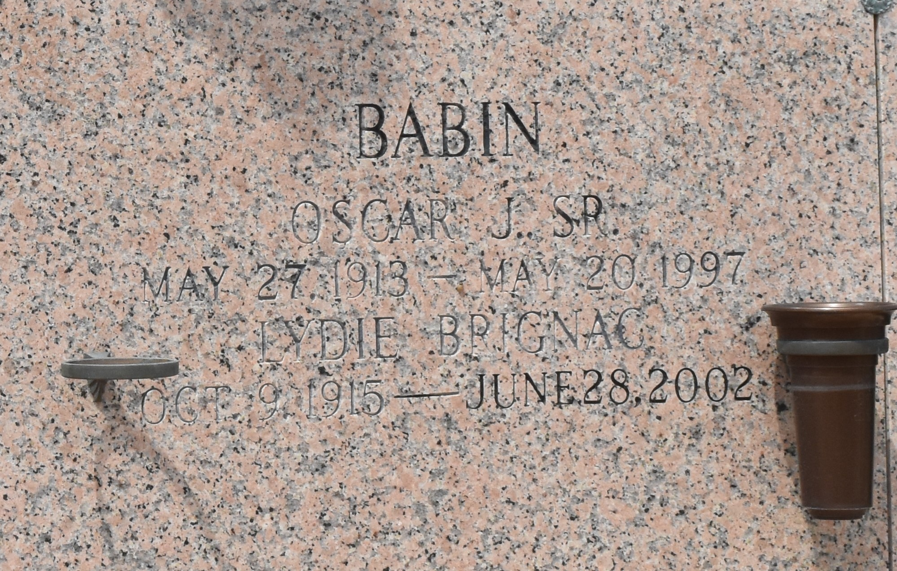

LAPLACE - Lydie Brignac Babin, 86, a native of Head of Island and resident of LaPlace for 65 years, died June 28. She was the wife of the late Oscar Babin Sr. and mother of Oscar Babin Jr. She was the daughter of the late John and Ella Brignac and sister of the late Louise Mitchell, Edna Dupuy, Odelia Hebert, Rowena Lambert and John, James and Russell Brignac. She is survived by one grandchild and two great-grandchildren.

Services were July 1 at St. Joan of Arc Catholic Church, LaPlace, with interment at St. John Memorial Gardens, LaPlace.

L'Observateur, LaPlace, Louisiana

Monday, July 8, 2002