Pearl (Vicknair) Badeaux

February 22, 1918 – December 13, 2010

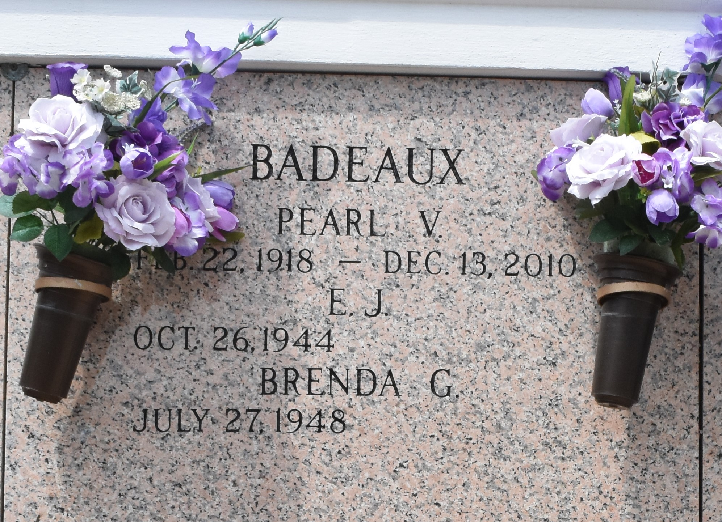

Pearl (Po-Po) Vicknair Badeaux passed away on Monday, December 13, 2010 at 5:30 am at Twin Oaks Nursing Home. Born February 22, 1918. Beloved wife of the late Harry U. Badeaux. Mother of E.J. Badeaux (Brenda), Marie Patke (Terry) and Harry Badeaux Jr. (Diane). Grandmother of Todd Badeaux (Kim), Jenny McElveen, Penny and Patrick Patke, Kelli Kelley (Trice). Step-grandmother of David Kuhn. Great-grandmother of Kay Latt, Bethany Badeaux, Derek Dominguez, Harrison Patke, Chance, Sydney and Rylee McElveen and Garrett and Haileigh Kelley. Loving aunt of Judy Duhe. Age 92 years. A native and resident of LaPlace.

Relatives and friends are invited to attend service. Visitation at Millet-Guidry Funeral Home, 2806 W. Airline, LaPlace, on Wednesday, December 15, 2010 from 5:00pm until 9:00pm and on Thursday from 8:00am until 9:45am. Followed by a Mass at St. Joan of Arc Catholic Church, LaPlace at 10:00am. Burial in St. John Memorial Gardens, LaPlace. The family would like to thank doctors and staff of Twin Oaks Nursing Home.

The Times-Picayune, New Orleans, Louisiana

Dec. 14, 2010