Donovan K. Bailey

December 2, 1983 – April 18, 2013

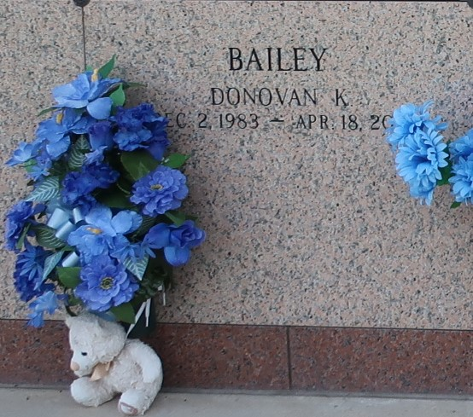

DONOVAN K. BAILEY on Thursday, April 18, 2013 at River Parishes Hospital, LaPlace, LA Son of Veronica Cook and Herman Bailey, Sr. Father of Danijah Vinnett and Chance Joseph. Brother of Herman Bailey, Jr. and Darius Bailey. Also survived by a host of nieces, nephews, cousins, other relatives and friends. Age 29 years. A native and resident of Reserve, LA.

Relatives and friends of the family, also pastors, officers and members of St. Matthew Baptist Church and all neighboring churches are invited to attend the funeral at St. Matthew Baptist Church, 604 E S Johnson Street, New Sarpy, LA on Saturday, April 27, 2013 at 11:00 AM Rev. Fred T. Porter, Pastor, Officiating Interment St. John Memorial Garden Cemetery, LaPlace, LA. Visitation at the above named church from 9:00 AM until service time SERVICED BY ROBOTTOM.

Times-Picayune, New Orleans, Louisiana

Apr. 25 to Apr. 26, 2013