Lodewijk “Leo” Bonne Bandsma

September 29, 1944 – October 14, 2012

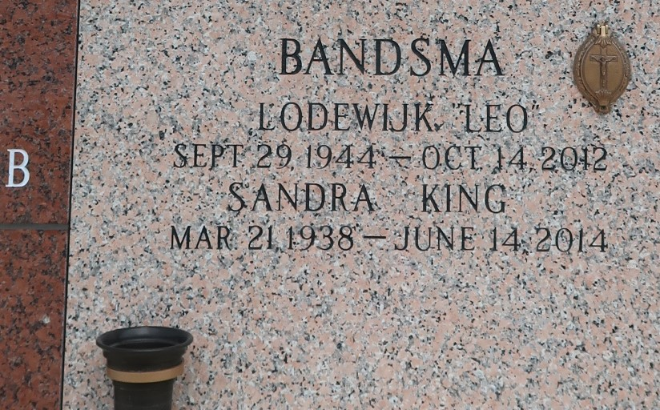

Lodewijk (Leo) Bonne Bandsma passed away on Sunday, October 14, 2012. Beloved husband of Sandra King Bandsma for 45 years. Father of Kristina Bandsma Miller and Elisa Bandsma Chapman (Stephen). Opa of Alex and Andrew Miller, and Jack, Thomas and Katherine Chapman. Son of the late Pieter and Neeltje Postma Bandsma. Brother of Herma Bandsma Guyt (Chiel), Gerda Bandsma Katoen (Cees), Pieternel Bandsma Klein (Ton), Bonne Bandsma (Irene) and Jiske Bandsma Twilt (Bram). Leo will always be remembered for his great love of the sea and ships. A kind, gentle, caring man who loved nothing more than spending time with his family, especially his grandchildren and his grand-dog, Audrey. He will be sadly missed by all who knew him. Age 68. A native of Den Helder, Netherlands and a resident of LaPlace, LA. Relatives and friends are invited to attend Memorial Services. Visitation at Ascension of Our Lord Catholic Church, 1809 Greenwood Dr., LaPlace, LA on Thursday, October 18, 2012 from 10:00 am to 11:00 am, followed by Mass at 11:00 am. Burial to be private at a later date. In lieu of flowers Masses preferred. Arrangements by Millet-Guidry Funeral Home, LaPlace, La.

The Advocate, Baton Rouge, Louisiana

Oct. 15 to Oct. 17, 2012