Don Banks

July 4, 1958 – April 15, 2003

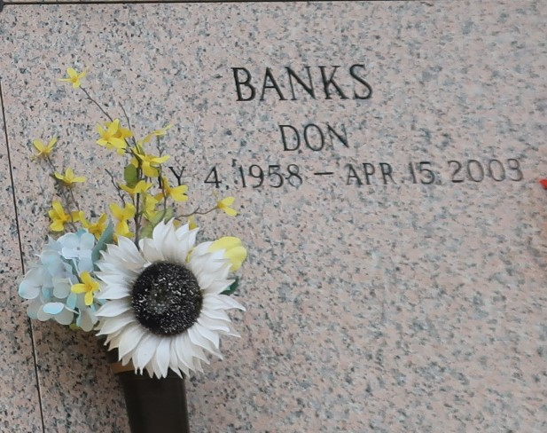

Don "Duffy" "Big Block" Banks, a truck driver, died Tuesday of undetermined causes at St. James Hospital in Lutcher. He was 44. Mr. Banks was born in LaPlace and lived in Reserve.

Survivors include his wife, Karen Mason Banks; five daughters, Davona Joseph, LaQuinta, Juvona and Desiree Banks and Ashley Cook; a son, Demichael Cook; a brother, Will Banks; and two grandchildren.

A funeral will be held Saturday at 10 a.m. at Beech Grove Baptist Church in Reserve. Visitation will begin at 9 a.m. Burial will be in St. John Memorial Gardens Mausoleum in LaPlace. The Baloney Funeral Home is in charge of the arrangements.

Times-Picayune, The (New Orleans, LA)

Friday, April 18, 2003