Mercedes (Lingo) Baracco

October 23, 1943 – June 20, 2017

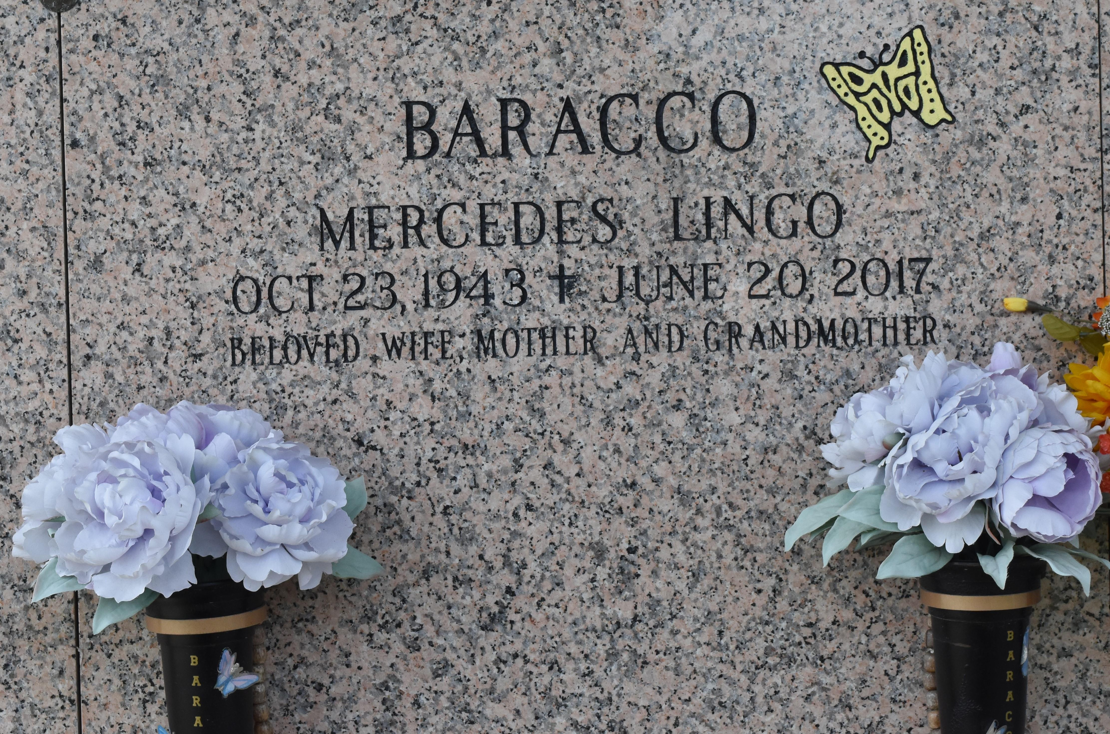

Mercedes "Sis" Lingo Baracco, 73, ascended into heaven on Tuesday June the 20th, 2017 surrounded by her loving family. A longtime resident of Jefferson Parish, Mercedes was a member of Our Lady of Divine Providence Parish, holding St. Joseph altars in her home for over 6 years. A truly one of a kind compassionate woman, Mercedes saw the world through the eyes of Jesus, holding true to the words of Hebrews 11:1, "Faith is confidence of what we hope for and assurance of what we do not see" as she developed a faith that could move mountains. Her heart of boldness and service was displayed through her everyday life reaching out to pray and encourage others wherever she went.

Born Oct 23, 1943, in New Orleans, LA Mercedes was the daughter of the late Mercedes and John Lingo Sr.. Mercedes was a devoted wife, to Salvadore "Sammy" Baracco Sr. of Metairie, beloved mother, to Clara "Missy" Powenski(Richard) of Boutte and Salvadore Baracco Jr. of Metairie. She was adored by six grandchildren Haile Powenski, Zachary Powenski, Salvadore Baracco III, Ashley Baracco, Stephanie Baracco, Stacy Baracco, and great granddaughter Ashlynn "Nae Nae" Baracco. Mercedes was loved by sisters Mary Mullen(Johnny) and Carol Firmin (Henry), brothers George Lingo(June), Earl Lingo(Kathy) and the late Johnny Lingo (Joyce). Mercedes was blessed with six godchildren, and numerous aunts, uncles, nieces and nephews whom cared for her greatly.

Family and friends are invited to attend the visitation at the Garden of Memories Funeral Home, 4900 Airline Drive, Metairie, LA on Monday, June 26, 2017 from 6:00 pm until 9:00 pm and the funeral mass will be held on Tuesday, June 27, 2016 at 11:00 am at the funeral home and the visitation will begin at 8:30 am until service time. Entombment will follow in St. John Memorial Gardens in Laplace, LA. Online condolences may be offered at [www.gardenofmemoriesmetairie.com](http://www.gardenofmemoriesmetairie.com/).

The New Orleans Advocate, Louisiana

Jun. 24 to Jun. 26, 2017