Klebert Joseph Barre

July 22, 1917 – December 7, 2015

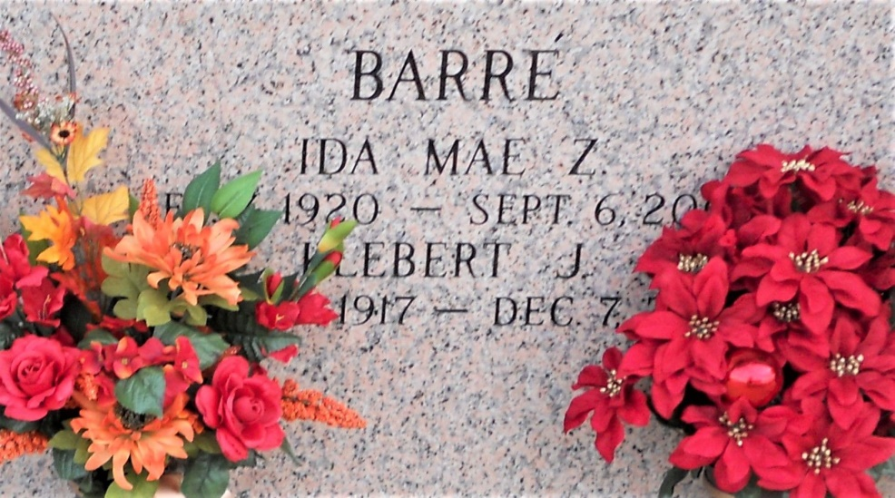

Photo by Team T Lo

Klebert Joseph Barré passed away on Monday, December 7, 2015. He was 98, a native of Edgard and a resident of Reserve.   
  
Beloved husband of the late Ida Zeringue Barré. Father of Farrel Barré (Sandra), Don Barré (Martha), Wendy Howes (Clarence) and Carrol Duhe (the late Ronald). Son of the late Martha Rodrigue Barré and Pierre Clebert Barré. Brother of the late Thelma Gillman, James Barré and Laurence Vicknair. Grandfather of Noelle Lindsay, John Howes, Kimberly Hildago, Robin Hebert, Chad Duhe, Brandon Barré, Bradley Barré, Bret Barré, Monica Bridges and Celeste Henson. Also survived by 19 great grandchildren and 3 great-great grandchildren.  
  
Relatives and friends are invited to attend the Funeral Mass at St. Peter Catholic Church, 1550 Hwy. 44, Reserve on Thursday, December 10, 2015 at 11:00 a.m. Visitation at the church from 9:00 a.m. to 11:00 a.m. Interment in St. John Memorial Gardens Cemetery.

Unknown source