Jason Paris Bartholomew

November 2, 1969 – August 8, 2020

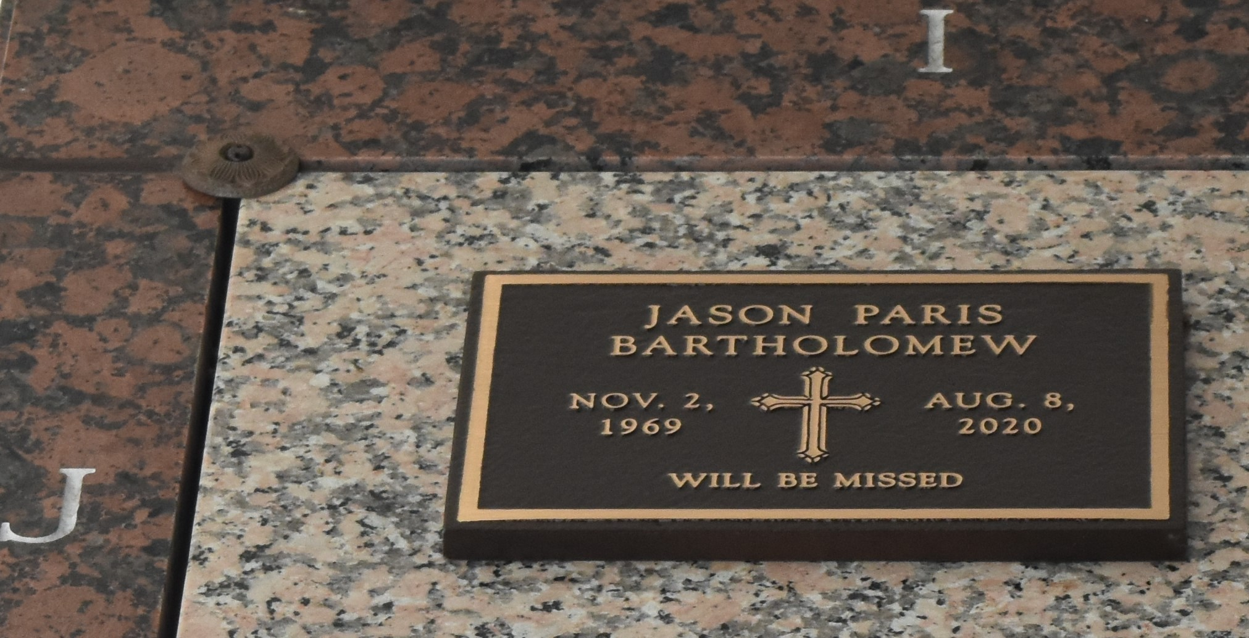

Jason Paris Bartholomew, age 50, passed away on Sunday, August 23, 2020 in New Orleans. He was born in New Orleans and a proud graduate of McDonough 35 Senior High School (1987) and Southern University at New Orleans. He served briefly in the United States Air Force and received an honorable discharge. Until his transition, Jason was an active member of the Yemassee Nation and the Washitaw Moorish Nation. Jason leaves to cherish his memory, sisters Allison Bartholomew and Jodi Hawkins (Derrick), brothers Eldridge Bartholomew, Jr. (Paulette) and Horatio Dumas (Nelda), aunts Jeanette Williams Landry (Reverend Reginald), Charlotte Caines Pittman (Willie), and Cheryl Caines Spann (Elder Miles), uncles Richard Caines and Michael Caines; devoted nephew Marcus Dorris, devoted cousin Pa Bey, devoted friends Steven and Janell St. Martin, godson Seth St. Martin and a host of nieces, nephews, cousins and friends. He was preceded in death by parents Eldridge "Bart" Bartholomew, Sr. and Jessie Paris Bartholomew; maternal grandparents, Wilson Paris, Sr. and Frances Chatman Paris Caines; paternal grandparents, Marjorie and Paul V. Bartholomew, Jr.; uncles Wilson Paris, Sr. and Ellis Caines, Jr., aunt Joyce Paris Frazier and cousin Lee Frazier. A Celebration of Life will be held at a later date.

Times-Picayune, New Orleans, Louisiana

Sep. 5 to Sep. 6, 2020