Bernadine (Williams) Batiste
September 12, 1960 – February 9, 2005

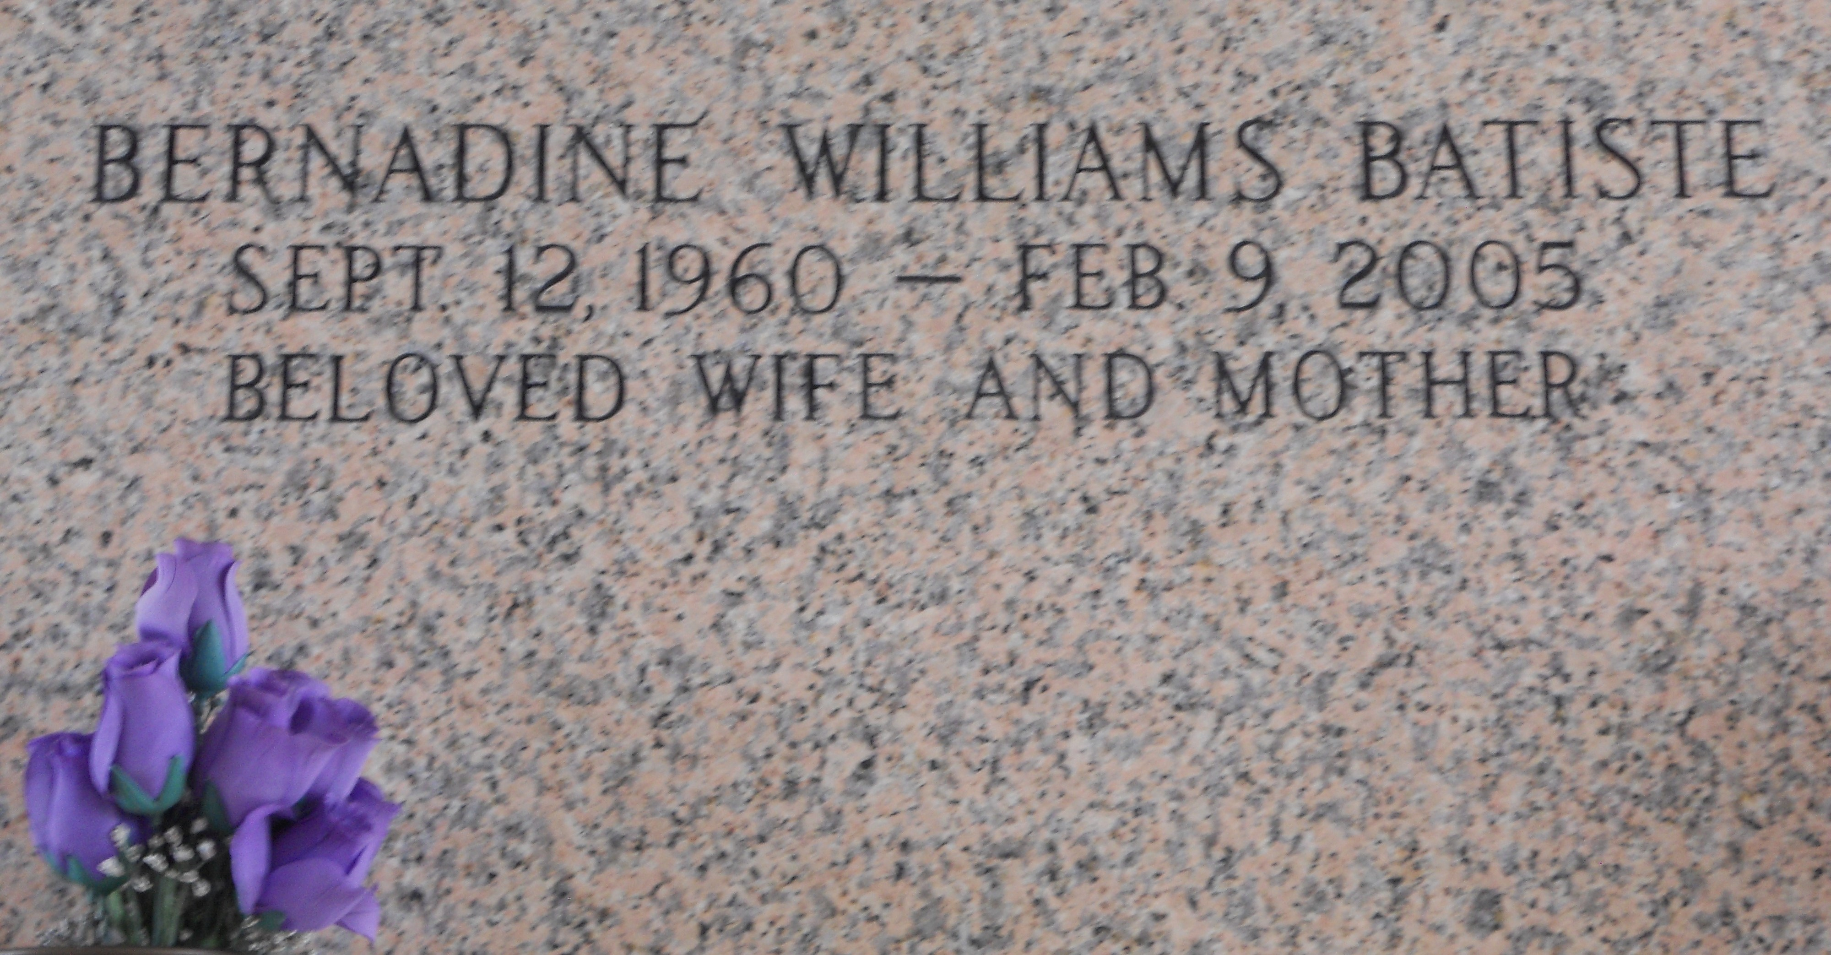

Photo by Team T Lo

Bernadine Williams Batiste On Wednesday, February 9, 2005 At Luling Living Center, Luling, La. Daughter Of Medrick Williams, Sr. And The Late Rosalie Banks Williams. Wife Of The Late Bruce Batiste. Mother Of Amber Lynn And Coy Williams, Maya Monique And Bruce Batiste, Jr. Sister Of Verna W. Warren (Benjamin), Aline Zeno (Edgar), Marva Lee Joseph (Melvin), Yvonne Smith (Juansley), Norma Dorrest, Marilyn Warren (Samuel), Joyce Bush (Michael), Marlene Watkins (Irvin), Sheryl Pierre (Alexis), Rose Francois (Tim), Deloyd Williams, Sr. (Sharon), Lionel Williams (Sheryl), Medrick Williams, Jr. (Gwen), And Gerald Williams (Shalonda). Also Survived By A Host Of Nieces, Nephews, Other Relatives And Friends. Age 44 Years. A Native Of Reserve, La And A Resident Of Laplace, La.

Relatives And Friends Of The Family, Also Pastors, Officers And Members Of Rising Star Baptist Church And All Neighboring Churches Are Invited To Attend The Funeral Service At Rising Star Baptist Church, 620 Cardinal Street, Laplace, La On Wednesday, February 16, 2005 At 11:00 Am. Reverend Donald August, Pastor, Officiating. Interment St. John Memorial Garden Cemetery, Laplace, La. Visitation At The Above Named Church From 9:00 Am Until Service Time. Serviced By Robottom
Times Picayune, New Orleans, Louisiana
February 15, 2005

