Marian (Telfair) Batiste

August 1, 1939 - December 17, 2015

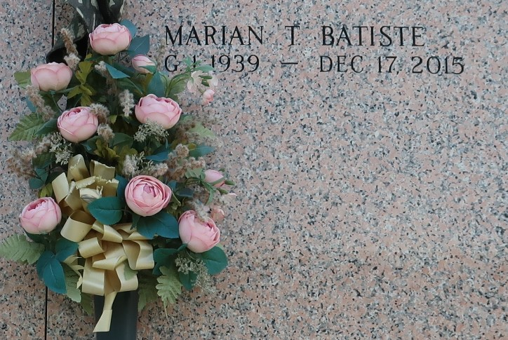

Marian Telfair Batiste at the age of 76 yrs. departed this earthly life on Thursday December 17, 2015 at her residence. She is survived by a host of sisters, brothers, nieces, nephews other relatives and friends. A native and resident of Garyville, La.

Relatives and friends of the family also Pastors, Officers and Members of Saint Mark Baptist Church of Mt. Airy, La and all neighboring churches are invited to attend the home going celebration on Wednesday, December 30, 2015 at 10:00 am at St. Mark Baptist Church 132 Marquez St. Mt. Airy, La. Elder Oscar Nelson officiating. Interment in St. John Memorial Garden of LaPlace, La. Visitation will be at the above named church from 8:30 am until service time. Bardell's Mortuary of Mt. Airy, La. in charge. Information: (985) 535-6837.

Times-Picayune, The (New Orleans, LA)

Sunday, December 27, 2015